A 'million word gap' for children who aren't read to at home

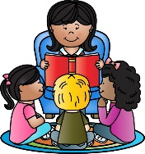
‘Learning to read well starts early, and good early language skills are the vital stepping stone. If children do not learn to speak and listen from an early age, along with developing their understanding of the meaning of words and stories, they will struggle to learn to read well when they get to primary school’ – Literacy Trust UK

Children learn to love the sound of language before they even notice the existence of printed words on a page. Reading books aloud to children stimulates their imagination and expands their understanding of the world. It helps them develop language and listening skills and prepares them to understand the written word.

If a child is never read to they will have heard approximately 4,662 words by the time they are 5 years old.
If a child is read to 1-2 times per week, they will have heard approximately 63,570 words by the time they are 5 years old.
If a child is read to 3-4 times per week, they will have heard approximately 169,525 words by the time they are 5 years old.
If a child is read to daily, they will have heard approximately 296,660 words by the time they are 5 years old.
If a child is read 5 books a day, they will have heard approximately 1,483,300 words by the time they are 5 years old.
Exposure to vocabulary is good for all children. Please read them a book today!
