Supporting your child at home
Year 2
Maths

By the end of Year 2, most children should be able to…
- Count up to 100 objects by grouping them and counting in tens, fives or twos.
- Explain what each digit in a two-digit number represents, including numbers where 0 is a place holder.
- Partition two-digit numbers in different ways, including into multiples of 10 and 1.
- Derive and recall all addition and subtraction facts for each number to at least 10, all pairs with totals to 20 and all pairs of multiples of 10 with totals up to 100.
- Add or subtract mentally a one-digit number or a multiple of 10 to or from any two digit number.
- Use practical and informal written methods to add and subtract two-digit numbers.
- Use the symbols +, -, x, ÷ and = to record and interpret number sentences involving all four operations
- Calculate the value of an unknown in a number sentence (e.g. □ ÷2 =6, 30 - □ =24.
- Visualise common 2-D shapes and 3-D solids; identify shapes from pictures of them in different positions and orientations.
- Sort, make and describe shapes referring to their properties.
- Use units of time (seconds, minutes, hours, days) and know the relationships between them; read the time to the quarter hour.
- Identify time intervals, including those that cross the hour.
- Use lists, tables and diagrams to sort objects.

How heavy?

You will need some kitchen scales that can weigh things in kilograms.
- Ask your child to find something that weighs close to 1 kilogram.
- Can he / she find something that weighs exactly 1 kilogram?
- Find some things that weigh about half a kilogram.

Out and about
During a week, look outside for ‘thirties’ numbers, such as 34 or 38, on house doors, number plates, bus stops, etc. How many can you spot? What is the biggest one you can find?
Next week, look for ‘fifties’ numbers, or ‘sixties’…

How much?
Once a week, tip out the small change from a purse. Count it up with your child.

Number facts You need a 1–6 dice. ◻ Take turns. Roll the dice. See how quickly you can say the number to add to the number on the dice to make 10, e.g.
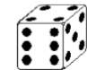and 6
- If you are right, you score a point.
- The first to get 10 points wins.
- You can extend this activity by making the two numbers add up to 20, or 50.

Speedy pairs to 10
Make a set of 12 cards showing the numbers 0 to 10, but with two 5s. If you wish, you could use playing cards.
- Shuffle the cards and give them to your child.
- Time how long it takes to find all the pairs to 10.
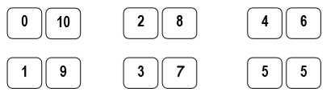
Repeat later in the week. See if your child can beat his / her time.

Guess my shape
Think of a 2-D shape (triangle, circle, rectangle, square, pentagon, hexagon or octagon).
Ask your child to ask questions to try and guess what it is.
You can only answer Yes or No. For example, your child could ask: Does it have 3 sides? or: Are its sides straight?
See if he can guess your shape using fewer than five questions.
Now ask them to choose a shape so you can ask questions.
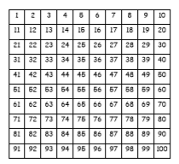
Board Games
Make a board like this.

The numbers are arranged differently from usual, but the games will still work if you use a normal snakes and ladders board.
- Roll a dice twice. Add the two numbers.
- Move along that number of spaces. Before you move, you must work out what number you will land on.
- If you are wrong, you don't move!
- The first to the end of the board wins. For a change, you could roll the dice and move backwards. Or you could roll the dice once, then move the number that goes with your dice number to make 10, e.g. throw a 3, move 7.

Straight lines
Choose 4 toys and lay them on the table in order of length. Use a ruler to measure each toy to the nearest cm.

Pasta subtraction
For this game you need a dice and some dried pasta or buttons.
- Start with a pile of pasta in the middle. Count them.
- Throw a dice. Say how many pieces of pasta will be left if you subtract that number.
- Then take the pieces of pasta away and check if you were right!
- Keep playing.
- The person to take the last piece wins !

Shopping maths
After you have been shopping, choose 6 different items each costing less than £1. Make a price label for each one, e.g. 39p, 78p. Shuffle the labels. Then ask your child to do one or more of these.
- Place the labels in order, starting with the lowest.
- Say which price is an odd number and which is an even number.
- Add 9p to each price in their head.
- Take 20p from each price in their head.
- Say which coins to use to pay exactly for each item.
- Choose any two of the items, and find their total cost.
- Work out the change from £1 for each item.

Circle trios
Draw four circles each on your piece of paper. Write four numbers between 3 and 18, one in each circle.
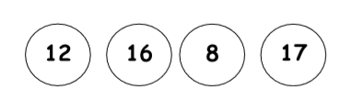
- Take turns to roll a dice three times and add the three numbers.
- If the total is one of the numbers in your circles then you may cross it out.
- The first to cross out all four circles wins.

