Dear Y2 Parents and Carers,

We are very pleased to welcome your children back to school and we hope that they are excited to be back and ready to learn. We are keen to support all our children to reintegrate into school so please do get in touch if you have any concerns or feel your child would benefit from additional support.

Below is information which we hope will be helpful to you-

PE
Our PE days are Wednesday and Thursday. PE kits should be in school on these days but may not be used as we will limit changing in school. PE will be outside where possible and appropriate. If your child wears earrings, please ensure that if they are unable to remove them by themselves, they are taken out on our PE days.

Outdoor learning
There is no such thing as bad weather, only inappropriate clothing! At The Ellis we are working hard to develop the outdoor environment and opportunities to learn outside and in Y2 we will be using our outdoor classroom and wider school environment as much as possible. This means that your child will need appropriate footwear and coats every day. Indoor pumps will be needed in school to protect our classrooms from the inevitable mud! We are very excited as we now have a fence around one section of our KS1 outdoor area. We have revamped the area and it is now ready to use as another learning environment for our children. Thank you for all your support during our nativity last year. We have used the funds raised to buy lots of new resources for our outdoor area as well as a new DT workbench and tools for indoors. So all that you see has been possible because of your generosity.

Reading Books
Your child will bring home a coloured banded reading book to share with you at home. Please record in their reading diary when they have read to an adult or maybe an older sibling. We ask that reading diaries are in your child’s book bag every day. If reading diaries are filled then we will send home a second diary free of charge, however if it is lost then we ask that a new one is bought from the office at the cost of £1. Your child is welcome to change their book any day of the week when they have completed it. Children should aim to read at home at least 3 times per week and dojos will be awarded for reading. We will also send home a Read Write Inc Phonics book which we will change once a week. This is so that your child can practise re-reading it a few times to develop fluency and automaticity. Once your child has completed the Read Write Inc Phonics programme and moves onto the Read Write Inc Spelling programme we will stop sending the Read Write Inc Phonics books as these are to develop their understanding of phonics, however we will continue sending the colour banded books.

Spelling books
The children will receive a spelling book. They will write in their new spellings on a Friday and bring their book home to practise. The spellings will also be on Spelling Shed each week. Please support your child in learning their spellings. They will be regularly assessed in their spellings. Their spelling books need to be in their book bag every Friday.

Home Learning
Each half term, children are expected to complete a home learning project linked to our topic. I have attached a sheet of a few ideas linked to our topic but feel free to create your own ideas! We are always intrigued to see what our superstars have been up to! Once they have completed their project or projects (as some children prefer to do a few shorter projects, whilst others like to complete one long one), please send them into school so we can share their learning with the class. (Photos or PowerPoints can be emailed to Mrs Fiddes and will be passed onto Year 2 staff to share). Please encourage your child to take pride in their home learning and aim for a quality piece that may have taken a few sessions to complete.

Online learning
Children are encouraged to be regularly practising spellings, time tables and areas of the curriculum online. As a school we have subscribed to websites to support the children with their learning. The children will be given their individual logins for TT Rockstars and Spelling Shed when they start back in September. Please support your child with their learning on these platforms.

Topmarks maths is also a fantastic website for the children to be practising all areas of the maths curriculum using interactive games.

You can find the Perfect Potters on Twitter @TheEllisY2
We use Twitter to share the learning we are doing at school, celebrate achievements and give information.

Our first topic begins with Marvellous Me (wk 1-3) and then Fire! Fire (Great Fire of London – Week 4-8) and below is an overview of the learning we will be doing this half term.
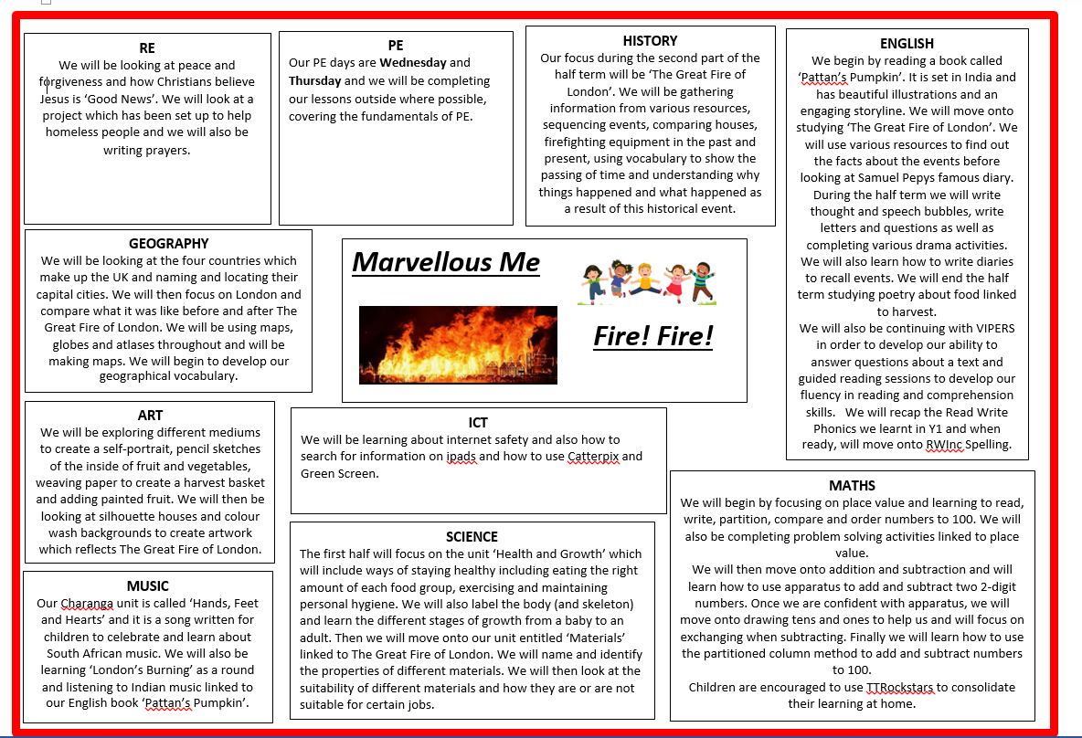
Home learning suggestions
Here are some learning activities that you can do with your children at home to support their learning in school.
Marvellous Me (Healthy and Growth)
- You all have amazing talents – send a video clip or photo of you showing us your talent e.g. gymnastics, cycling, dancing, footballing, cooking etc.
- Cook healthy recipes- bring photographs or recipes to share.
- Write acrostic poems for different fruit.
E.g. Green or red
Really juicy
Amazing to eat
Perfect for a snack
Eat them all
Super sweet
- Find out about where different foods come from.
- Make pieces of art using fruit and vegetable prints.
- Ask your friends and family about their favourite foods and record as a tally.
- Find different ways of sorting fruit and vegetables and record in a venn or carol diagram.
- Create a menu for your dream meal.
Fire! Fire! (Great Fire of London)
- Do some research about London nowadays – landmarks etc and then look at what London was like in 1666 and compare.
- Create a collage of a fire using different materials.
- Look at some Tudor houses and make pencil sketches of them.
- Explore colour mixing using red, orange and yellow. Create different shades and tones.
- The fire started in a bakery so how about tasting some different breads and writing a review about them.
- British Bake Off style – try baking bread! Can you add some flavour such as garlic, cheese or raisins?
- Make a model of the city using lego and re-enact the fire spreading.

You can choose which of these activities you would like to do. You do not need to do all of them! We also know that you and your children have lots of original and creative ideas of your own. We love to see these too! Please encourage your child to bring their learning into school to share.
If you have any questions, queries or worries then please get in touch via the phone or email. We know that there will be a whole range of feelings about the return to school, from excitement to anxiety but are ready to support all our learners and to enjoy learning together again.
Thank you for your continued support.
Best wishes,
The Y2 Team.

