Dear Y1 Parents and Carers,

We are very pleased to welcome your children back to school and we hope that they are excited to be back and ready to learn. We are keen to support all our children to reintegrate into school so please do get in touch if you have any concerns or feel your child would benefit from additional support.
Below is information which we hope will be helpful to you-

PE
Our PE days are Wednesday and Friday. PE kits should be in school on these days but may not be used as we will limit changing in school. PE will be outside where possible and appropriate.

Outdoor learning
At The Ellis we are working hard to develop the outdoor environment and opportunities to learn outside and in Y1 we will be using our outdoor classroom and wider school environment as much as possible. This means that your child will need appropriate footwear and coats every day. Indoor pumps will be needed in school to protect our classrooms from the inevitable mud! Please ensure your child has some wellies and a waterproof coat.

Reading Books
Reading is a focus at The Ellis. The children will receive a reading record. Please record in their reading diary when they have read to an adult or maybe an older sibling at home. We ask that reading diaries are in your child’s book bag every day so that we can reward regular reading. If reading diaries are filled then we will send home a second diary free of charge, however if it is lost then we ask that a new one is bought from the office at the cost of 1.
A reading book will be given to your children, based on the reading book band colours, by the end of the first week in school. Children can swap these books as often as they like but it is their responsibility to look after them and return them at least once a week. Children should aim to read at home at least 3 times per week and dojos will be awarded for reading.
The children will also receive a book every Friday linked to their phonics level and the Read, Write inc programme. These will be monitored to ensure they are returned. Unfortunately, the books are new and have cost the school a substantial amount of money so we would appreciate your cooperation with this.

Spelling books
The children will be receiving spelling books. They will be given 5 new spellings every week which they will bring home on a Friday to practise. Please support your child in learning their spellings by copying them out or playing games like hangman with. They will be tested on these the following Friday. Their spelling books need to be returned by then.

Home Learning
Each half term, children are expected to complete a home learning project linked to our topic. I have attached a sheet of a few ideas linked to our topic but feel free to create your own ideas! We are always intrigued to see what our wonderful children have been up to! Once they have completed their project or projects (as some children prefer to do a few shorter projects, whilst others like to complete one long one), please send them into school so we can share their learning with the class. (Photos or PowerPoints can be emailed to Mrs Fiddes and will be passed onto Year 1 staff to share). Please encourage your child to take pride in their home learning and aim for a quality piece that may have taken a few sessions to complete.

Our first topic is ‘Marvellous Me’. Below is an overview of the learning we will be doing this half term.

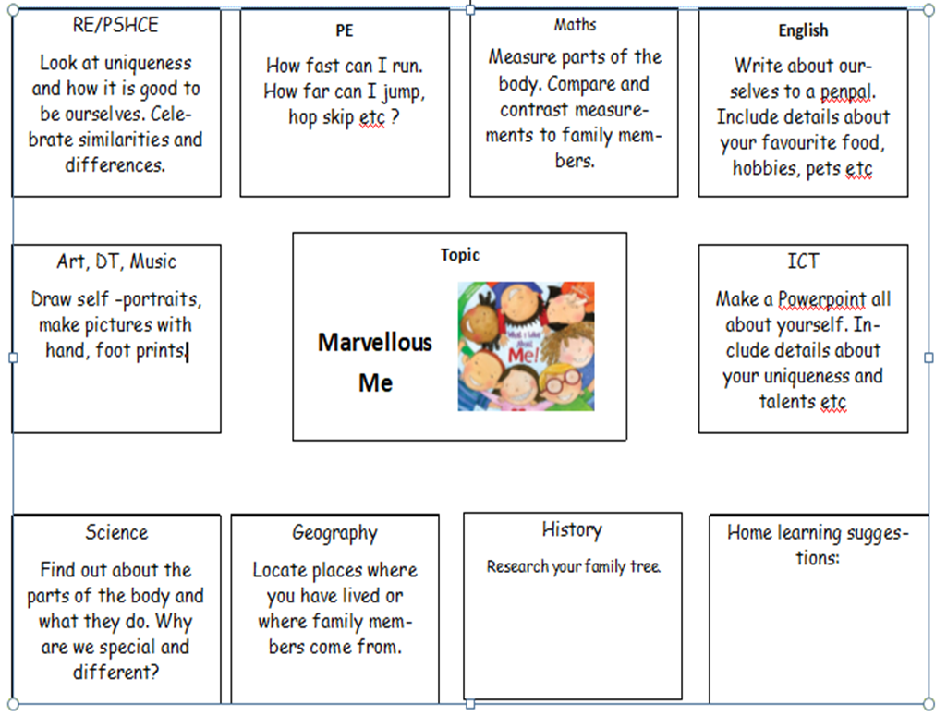

Online learning
Children are encouraged to be regularly practising spellings, time tables and areas of the curriculum online. As a school we have subscribed to websites to support the children with their learning. The children will be given their individual logins for Spelling Shed and Epic. Please support your child with their learning on these platforms. If logins have been misplaced I can issue new ones.

Topmarks maths is also a fantastic website for the children to be practising all areas of the maths curriculum using interactive games.

You can find the Wise Woollvins on Twitter @TheEllisY1
We use Twitter to share the learning we are doing at school, celebrate achievements and give information.

If you have any questions, queries or worries then please get in touch via the phone or email. We know that there will be a whole range of feelings about the return to school, from excitement to anxiety but are ready to support all our learners and to enjoy learning together again.
Thank you for your continued support.
Best wishes,
The Y1 Team.

