Dear Y6 Parents and Carers,

We are very pleased to welcome your children back to school and we hope that they are excited to be back and ready to learn. We are keen to support all our children to reintegrate into school so please do get in touch if you have any concerns or feel your child would benefit from additional support.

Below is information which we hope will be helpful to you-

PE
Our PE days are Tuesday and Friday. PE kits should be in school on these days but may not be used as we will limit changing in school. PE will be outside where possible and appropriate.

Outdoor learning
There is no such thing as bad weather, only inappropriate clothing! At The Ellis we are working hard to develop the outdoor environment and opportunities to learn outside and in Y6 we will be using our outdoor classroom and wider school environment as much as possible. This means that your child will need appropriate footwear and coats every day. Indoor pumps will be needed in school to protect our classrooms from the inevitable mud!

Reading Books
Your child will have already brought home a reading book to share with you at home. Please record in their reading diary when they have read to an adult or maybe an older sibling. We ask that reading diaries are in your child’s book bag every day so that we can fill them in when they have taken part in reading in school. If reading diaries are filled then we will send home a second diary free of charge, however if it is lost then we ask that a new one is bought from the office at the cost of £1. Your child is welcome to change their book any day of the week when they have completed it but it is their responsibility to ensure books are changed regularly. Children should aim to read at home at least 3 times per week and dojos will be awarded for reading.

Spelling books
The children are once again receiving spelling books. They will write in their new spellings on a Monday and bring their book home to practise. Please support your child in learning their spellings. They will be regularly assessed in their spellings. Their spelling books need to be in school every Monday and Friday.

Home Learning
Each half term, children are expected to complete a home learning project linked to our topic. I have attached a sheet of a few ideas linked to our topic but feel free to create your own ideas! We are always intrigued to see what our superstars have been up to! Once they have completed their project or projects (as some children prefer to do a few shorter projects, whilst others like to complete one long one), please send them into school so we can share their learning with the class. (Photos or PowerPoints can be emailed to Mrs Fiddes and will be passed onto Year 6 staff to share). Please encourage your child to take pride in their home learning and aim for a quality piece that may have taken a few sessions to complete.

Online learning
Children are encouraged to be regularly practising spellings, time tables and areas of the curriculum online. As a school we have subscribed to websites to support the children with their learning. The children will be given their individual logins for TT Rockstars and Spelling Shed. Please support your child with their learning on these platforms. If logins have been misplaced I can issue new ones.

Topmarks maths is also a fantastic website for the children to be practising all areas of the maths curriculum using interactive games.

You can find the Determined Dahls on Twitter @Y6TheEllis
We use Twitter to share the learning we are doing at school, celebrate achievements and give information.

Our first topic is The Terrible Tudors and below is an overview of the learning we will be doing this half term.
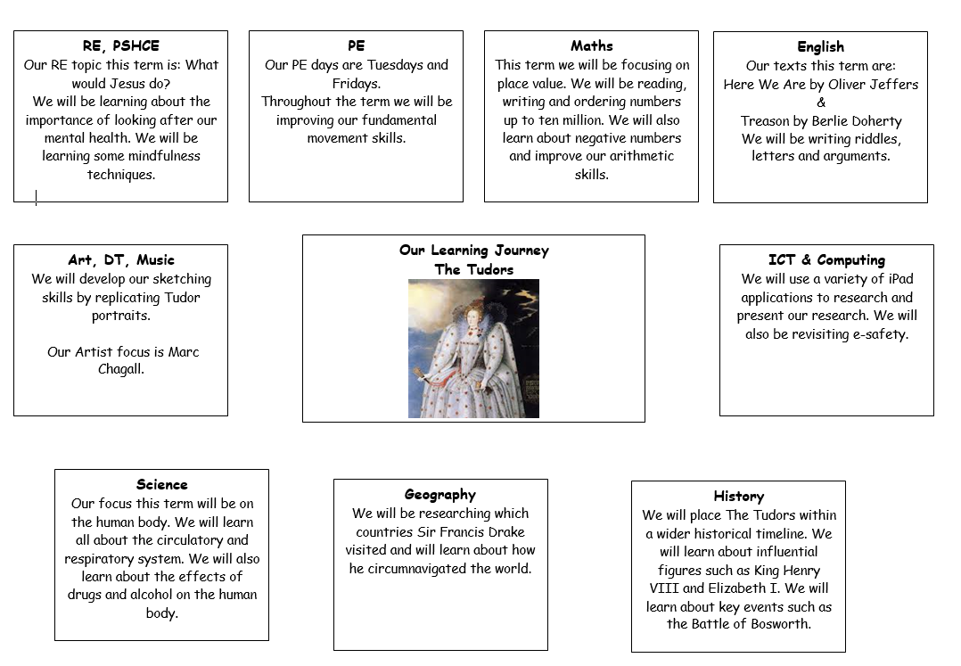

Home learning suggestions
Here are some learning activities that you can do with your children at home to support their learning in school.
- Find out about the clothes worn by Tudors. You could compare Tudor clothing with modern dress. You could present what you find through pictures, photos, fabric creations or writing.
- Create a map of Tudor London. What is the same and different about the geography of the city then and now?
- Research and create a family tree of the Tudor Royal family. You could also create and present your own family trees.
- Draw a self-portrait in the style of a Tudor artist.
- Research or write a Tudor menu. You could even try to make some food following a Tudor recipe!
- Write a list of 10 questions you would like to ask a person who lived in Tudor times.
- Create a Tudor Rose and investigate the lines of symmetry.
- Create a bar graph showing how long each of the Tudor monarchs reigned.
- Find out about a Tudor invention and create a labelled diagram of it.
- Make a fact sheet about Tudor ailments and their cures.
- Create a quiz to test the class on their knowledge of Henry VIII’s wives.
- Write a dairy of a day in the life of Shakespeare.
- Make a 3D model of a Tudor building.

You can choose which of these activities you would like to do. You do not need to do all of them! We also know that you and your children have lots of original and creative ideas of your own. We love to see these too!
Please encourage your child to bring their learning into school to share.

If you have any questions, queries or worries then please get in touch via the phone or email. We know that there will be a whole range of feelings about the return to school but we are ready to support all our learners and to enjoy learning together again.
Thank you for your continued support.
Best wishes,
The Y6 Team.

