**Design your own pirate flag .**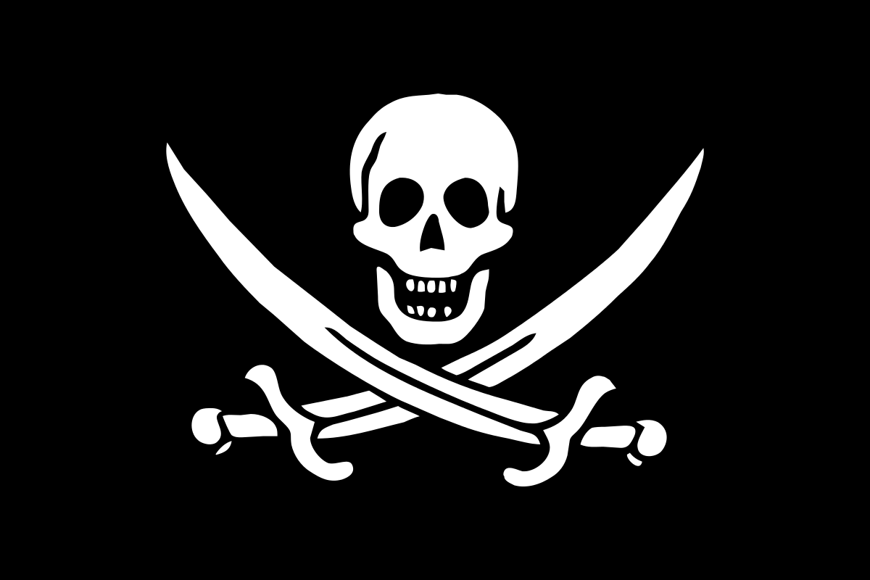

Challenges:

1: make it symmetrical

2: colour in using fractions, colour ½ in one colour, ¼ in a different colour etc

**Design a pirate boat.**

Will it float?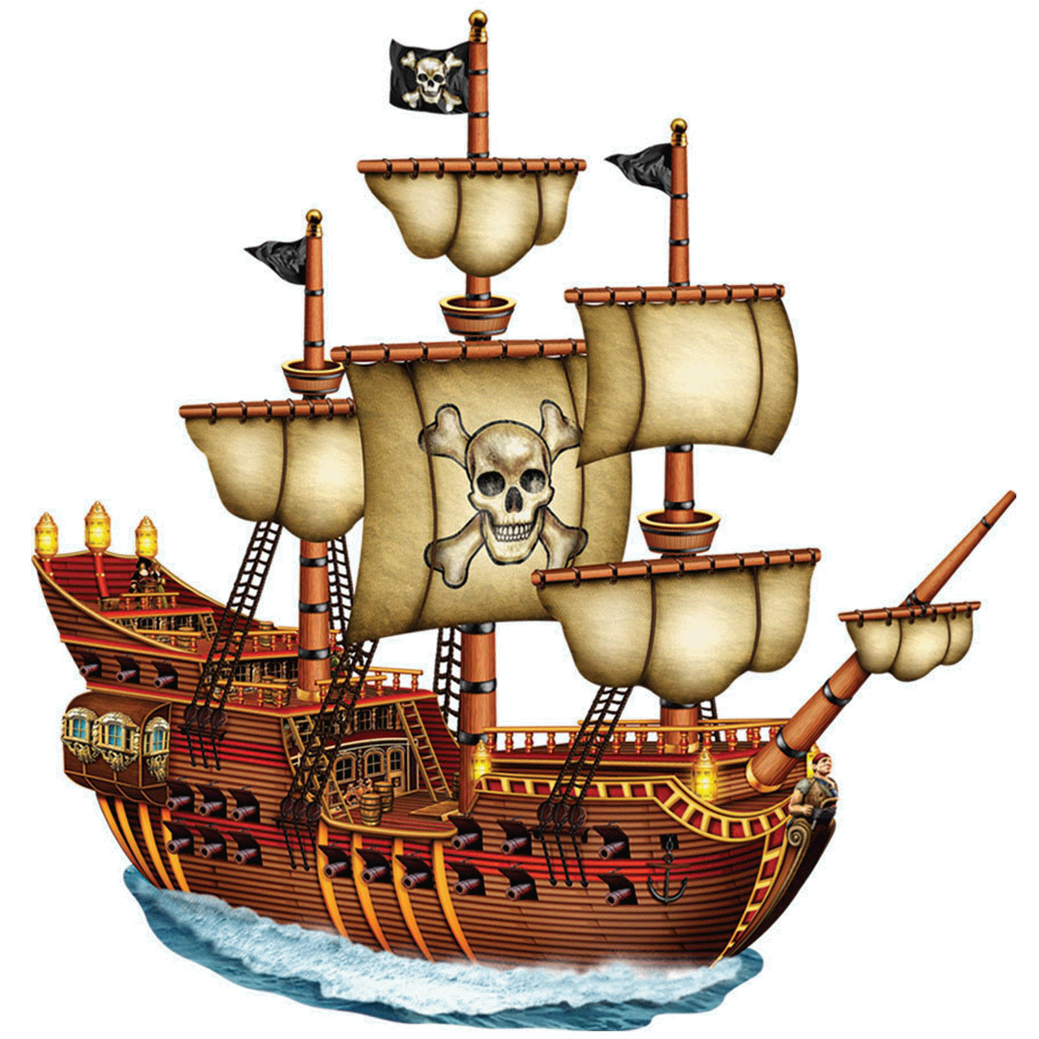

**Design and make your own treasure chest.**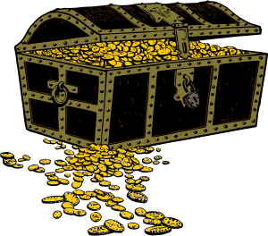

Visit the library and find books about pirates. You could look for both fiction and non-fiction books. Write a book review about your favourite book.

**Make a treasure map complete with co-ordinates**

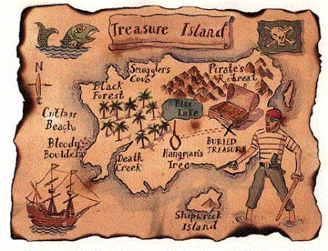

**Make a telescope**

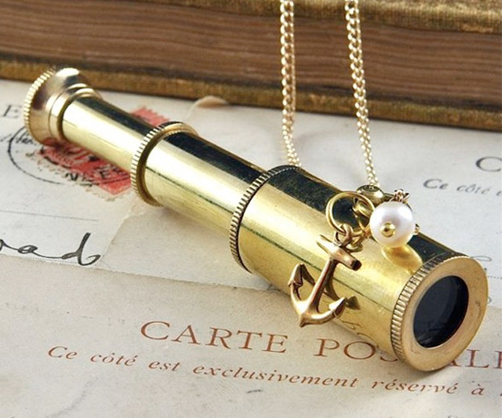

Pirates have left you stranded on a desert island! What would you need to survive?

It’s time to get your ‘scientist hat’ on and design your very own ‘survival’ invention!

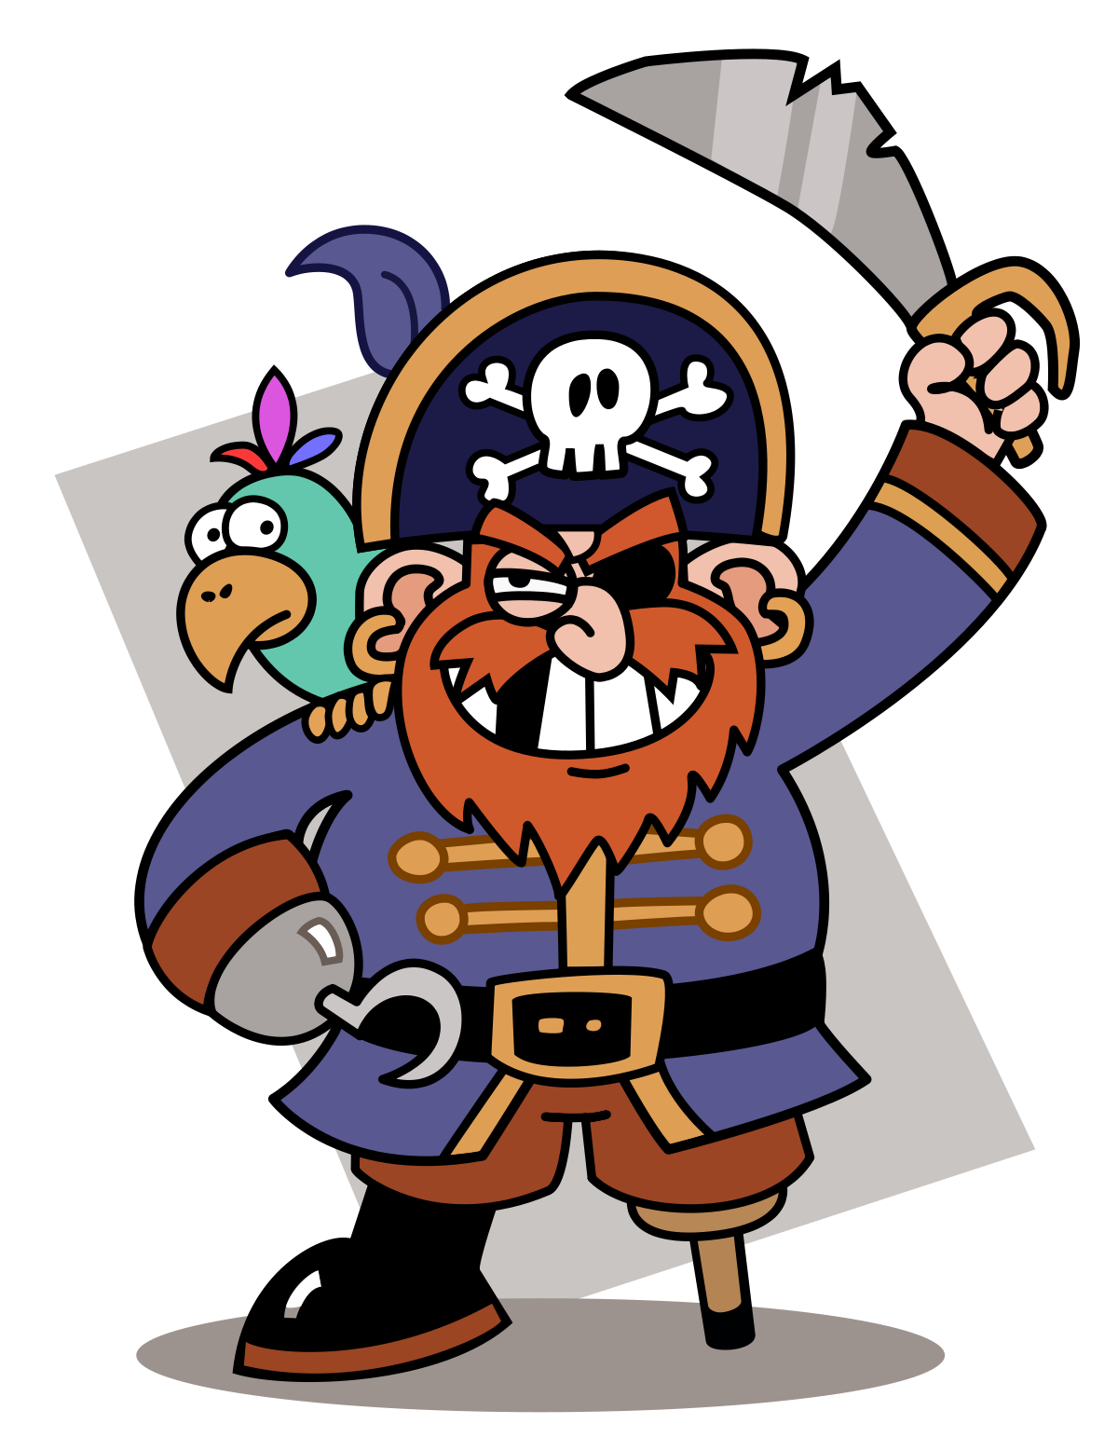**Pirates**

**Home-Learning**

**Year 4**

**Spring 2**

**Make your own pirate hat**

**Research famous pirates**

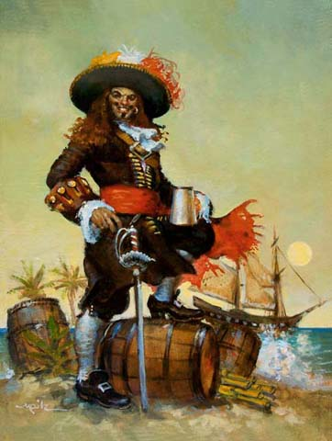

**Make a pirate hat**

