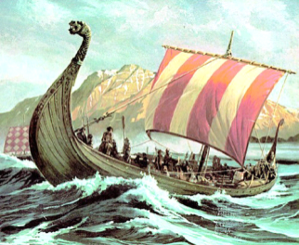
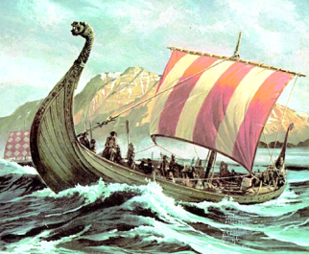
Vicious Vikings
Home learning ideas

Here are some learning activities that you can do with your children at home to support their learning in school.
- Design and make a Viking helmet or shield
- Make a Viking themed board game
- Write your name in Viking runes
- Write and perform a rap about the Vikings
- Design a piece of Viking jewellery
- Draw and label a Viking long boat or longhouse
- Make a Viking menu
- Create a fact file about a Viking God or Goddess
- Write your own Viking saga
- Research a British Viking settlement
- Make a collage depicting a Viking raid
- Create a comic strip about a Viking adventure
- Create a PowerPoint quiz about Viking warriors
- Imagine you could meet a Viking. Write a list of questions that you would ask
You can choose which of these activities you would like to do. You do not need to do all of them! We also know that you and your children have lots of original and creative ideas of your own. We love to see these too!
Please encourage your child to bring their learning into school to share.

