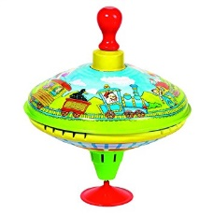
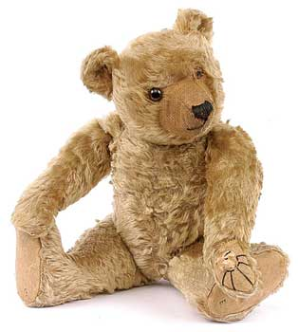
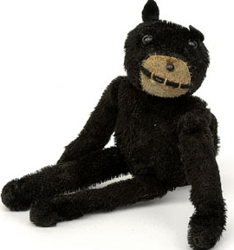
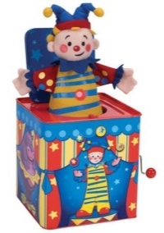
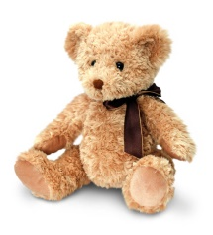
Toy Story
Home learning Ideas
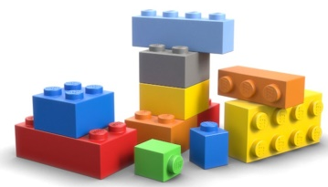
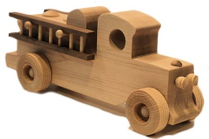

Here are some learning activities that you can do with your children at home to support their learning in school.

- Research about old teddies and how they have changed over the years.
- Design an outfit for a build-a-bear teddy. What sound would you give it?
- Research old toys – can you make a time-line.
- Take your teddy out for a day. Can you show us photos and write about where you went?
- Find pictures of toys and label the materials they are made from e.g metal, wood, fabric.
- Write about how toys have changed over the years – think about the changes in materials that are used to make them.
- Draw a picture and write a description of your favourite toy.
- Choose a toy and list as many adjectives as you can to describe it.
- Make a simple toy from the past (pop up toys, wooden peg dolls…)
- Ask parents/grandparents what their favourite toys were. Can you find a picture of them on the internet?
- Choose a toy from an online shop. How much is it? What coins/notes would you use to buy it? Use the exact money!
- Can you invent a toy for the future? Draw a picture or write a description of it.
- Make a board game. Does it have a design purpose e.g. to help counting/addition?
- Use lego to create a toy shop.

You can choose which of these activities you would like to do. You do not have to do all of them!
Please encourage your child to bring their learning into school to share.

