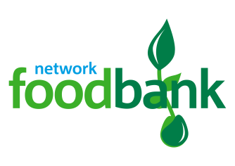

This autumn can you help support Barnsley foodbank with our harvest appeal?

We are part of The Trussell Trust’s foodbank network, which distributed 1,332,952 three day emergency food supplies to people in crisis in 2017/18, a 13% increase on the previous year. Sadly, this figure is not expected to reduce significantly any time soon. Despite this, we can still make a difference. By working together with our community we are tackling poverty and transforming lives here in Barnsley.

Our foodbank supports individuals and families in crisis by providing emergency food supplies donated by churches, schools, local businesses and the general public. We welcome people with a cup of tea, provide a listening ear, and if needed, signpost people to agencies that are able to help resolve longer-term problems.

We rely on voluntary donations of both food and money to keep our foodbank running and provide this vital service to our community. A large proportion of our food donations come from Harvest collections, so we need as many people as possible to support us at this time. Could you support our harvest appeal?

Foodbanks across the country are seeing greater demand for their services, so we urgently need your support to stock up on a range of items. This will ensure we can continue to provide parcels over the coming months. We also want to collect monetary donations to help cover the costs of storing and distributing the food.

If you would like to take part, you can organise a collection in your School and arrange a time to drop it off or we can come and pick your donations up.

I hope you can support our harvest appeal, helping us raise vital food and funds this autumn. If you would like to help, please get in contact with manager@barnsley.foodbank.org.uk us on 01226 235280

Thank you for your time and support.

Yours sincerely,

Suzanne Storey
Barnsley Foodbank Manager

