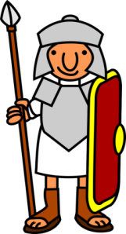
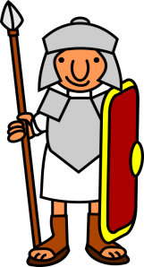
ROMANS
Home learning ideas.
Here are some learning activities that you can do with your children at home to support their learning in school.
- The Romans wore togas. See if you can make a toga and take a photo of you wearing it! Write some instructions for how you made the toga.
- Research Roman tools and make a model of one.
- Draw and describe a Roman chariot. What were the chariots used for? Who used them?
- Draw a picture of a Roman God or Goddess. Add information to the picture. What were they God of? Did they have special powers?
- Find out about a Roman building and then make a model of it.
- Write a list of 10 questions you would like to ask a Roman soldier who has come to Britain.
- Make some Roman Honey Cakes or any other Roman food.
- Make your own Roman mosaic using cut paper, pasta shapes, seeds etc. Keep the design simple.
- Write the words for a marching song that the Romans could sing while they marched.
- Choose a times table and write it out using Roman Numerals.
You can choose which of these activities you would like to do. You do not need to do all of them!
Please encourage your child to bring their learning into school to share.

