Dear Parents,

Thank you for coming to parents evening last night, we hope you enjoyed looking at your child’s book. It was lovely to be able to share their learning with you all. We apologise for running behind and appreciate your patience and understanding. Following on from last night here are a few things that we hope will be of use to you.

Thank you
Thank you for all your support with extra work at home. It makes such a difference and a big pat on the back to all the children for their extra effort outside school - you really are ‘Terrific Tigers!’. As mentioned before, if you would like any more booklets just let us know and we will sort some out for you. Next week we will send home the ones parents asked for last night. Although we do want to stretch and challenge all our children, we don’t want any child to feel overwhelmed and also want to ensure they have plenty of time to be ‘children’; to play, get messy, relax, attend clubs and do everything 6 and 7 year olds should be doing! Please don’t let them get bogged down. Balance is key and we want happy, energised children.

Writing
Some parents asked how they could support writing at home. We have put together a pack of ’10 story starter ideas’ which we have attached to this email. It can sometimes be tricky thinking of things to do with your child for writing at home, but we hope that these story openers might inspire some budding authors. The stories do not need to be overly long and feel free to send them in for us to read at story time. If you would like a paper copy sending home, please reply to this email and we will get them photocopied and sent out. Don’t forget your capital letters, full stops, clear handwriting (with ascenders and descenders) and exciting, powerful word choices Y2!

Mental Maths
With several parents we discussed the mental maths objectives which we are currently working on with the children in Y2. We thought it might be helpful if we listed these for you so that you can practise at home with them.
- Recall multiplication and division facts for 2, 5 and 10 times tables; (e.g. 8x10=80 80÷10=8)
- Recall numbers which make 10 (1+9, 2+8, 3+7, 4+6, 5+5, 0+10);
- Recall multiples of ten which make 100 (10+90, 20+80, 30+70, 40+60, 50+50, 0+100);
- Recall numbers which make 20 (e.g. 1+19, 2+18, 13+7, 15+5, 20+0);
- Recall and use addition and subtraction facts to 20 (e.g. 8+3, 6+5, 13+2… 18-2, 15-4, 19-4…);
- Recall doubles up to 20+20 (e.g. double 8, double 11, double 16, double 19);
- Recall halves up to half of 40 (e.g. half of 34, half of 12, half of 8, half of 26).

‘Hit the button’ is a fantastic online free website which our children love. You can select all the objectives above and it runs 1 minute challenges to see how many the children can get right. Rapid recall is achieved by regular practise and this programme is one good way of practising, along with TT Rock stars for multiplication. Here are the details of how to select the appropriate objectives for Y2.

Website - https://www.topmarks.co.uk/maths-games/hit-the-button

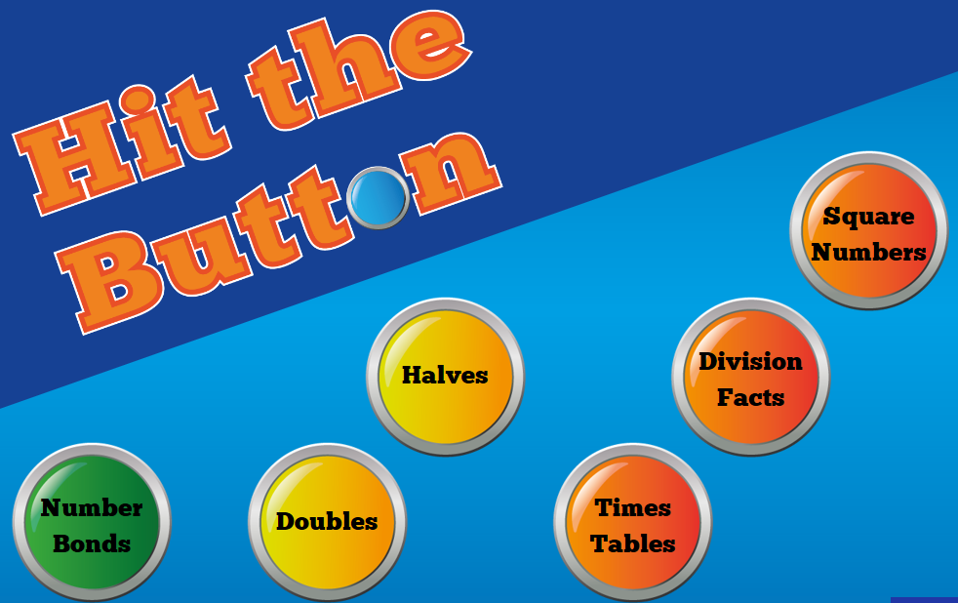

Select Numbers Bonds buttons and the ones with arrows next to them are Year 1 and Year 2 objectives.
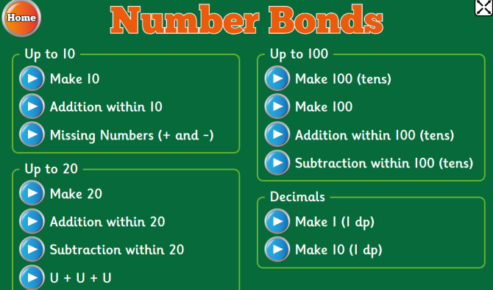

Select Doubles buttons and the ones with arrows next to them are Year 1 and Year 2 objectives.
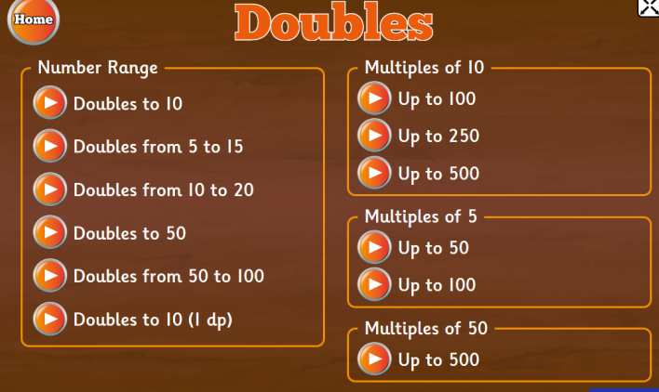

Select Halves buttons and the ones with arrows next to them are Year 1 and Year 2 objectives.
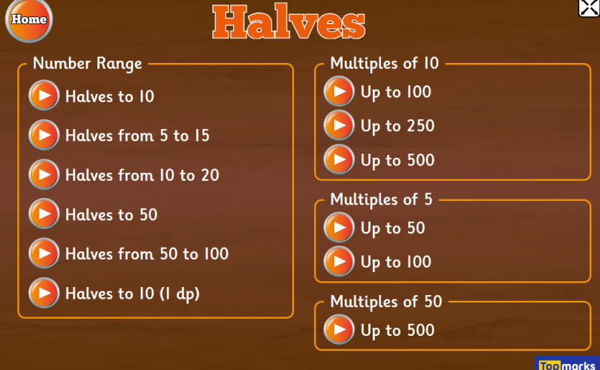

Select Times Tables buttons and the ones with arrows next to them are Year 1 and Year 2 objectives. (2x, 5x, 10x)
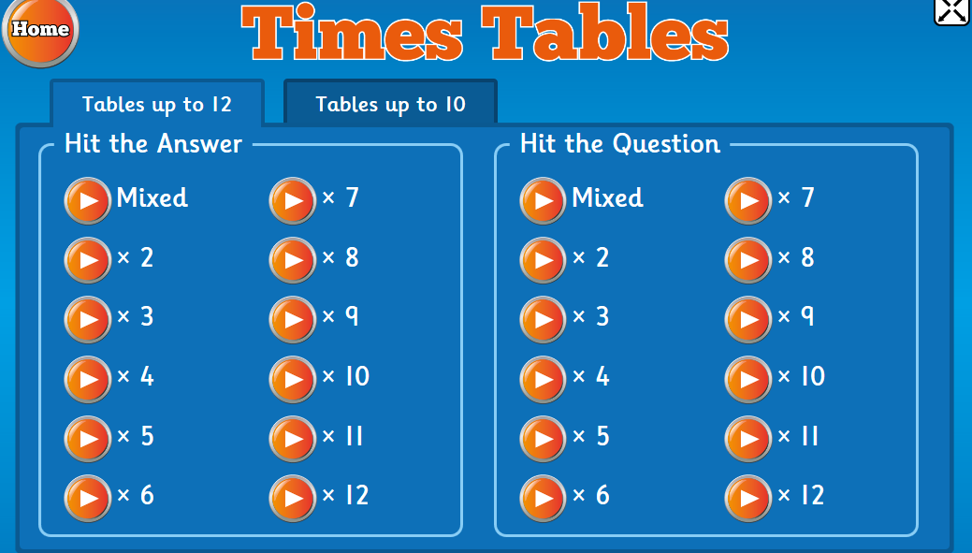

Select Division Facts buttons and the ones with arrows next to them are Year 1 and Year 2 objectives. (÷2, ÷5, ÷10)
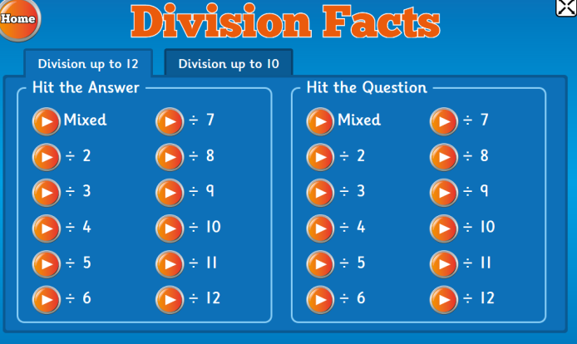

NB – Square numbers are KS2.

PE kits
Quick reminder: Our PE days are Monday and Wednesday. Please ensure your child has their kit in school on these days as we have had quite a few children without their PE kit over the last few weeks. Thank you for your support.

Residential to Whirlow Farm
As today (Fri 22nd March) is payment deadline day, we can now organise groupings. Therefore, by
Easter we will send home the exact dates your child will be going to Whirlow Farm. We have asked
each child to tell us the names of 2 or 3 people who they would choose to go with. We have
explained to the children that we can’t promise that they will go with all 2 or 3 but have reassured
them that they will be going with at least 1 person out of the ones they have said. We hope you will
understand all the factors we have to take into consideration when organising the groups. We have
20 boys and 9 girls in our class and have to take into account not only friendships, but also the
logistics of bedrooms. We have two different accommodation venues (both within Whirlow Farm
grounds itself). The barn has 6 rooms with bunk beds in each (e.g. 6 rooms of 2) and the hall has 2
rooms with 3 sets of bunk beds (e.g. 2 rooms of 6). So as you can imagine it is a big task to sort
groups! Last year all the groups had a fantastic time and we are sure that this year will be no
different! We will be taking 2 groups of 10 children and 1 group of 9 children. Each group will be
accompanied by Mrs Trotter and another member of staff. A quick reminder that we have our
Whirlow meeting on Tuesday 21st May, 5pm when we will go through arrangements, provide you
with a pack and answer any questions you may have. Finally, we can already see how ready our
children will be for this adventure! They really have matured since September and we can’t wait to
help them make memories which will last them a lifetime!

We hope all this information is helpful and once again thank you for all your ongoing support.

Kind regards,
Mrs Trotter, Miss Beresford and Mrs Green

