Dear Parents/Carers,

**Celebrate reading at our half-price book fair!**

The book fair will be arriving in school soon, with hundreds of new children’s books to browse and buy, and as an added bonus, ***everything will be half-price.*** The lowest price on each book can be halved and this will be the purchase price. If you are unable to come to our book fair but would still like your child to buy a book, you are welcome to send the money into school and a staff member will help your child choose a book.

Numbers of each book are limited, however, orders can be placed and will be delivered at the end of the book fair week.   
  
Where?

Our book fair will be held in the hall.

When?

Friday 23rd November: 3:20 -4pm

Monday 26th November: 8:20 -8:50am

Tuesday 27th November : 8:20 -8:50am

Wednesday 28th November: 8:20 -8:50am

Thursday 29th November: 3:20-4pm

Friday 30th November: 8:20 -8:50am

What’s on offer?

Hundreds of half price books including:

The Ice Monster, David Walliams - – RRP £14.99, Scholastic Price £9.99, **Half Price Book Fair £5.00**

[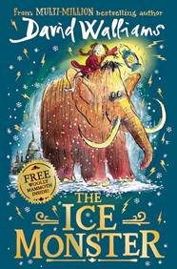](https://d3ddkgxe55ca6c.cloudfront.net/assets/t1539689265/a/21/8e/186891-ml-1772499.jpg)

Diary of a Wimpy Kid: The Meltdown – RRP £12.99, Scholastic Price £8.99, **Half Price Book Fair £4.50**

[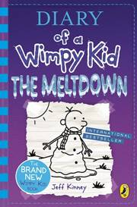](https://d3ddkgxe55ca6c.cloudfront.net/assets/t1540463819/a/cc/a6/186317-ml-1775795.jpg)

The Wonky Donkey – RRP£6.99, Scholastic Price £4.99, **Half Price Book Fair £2.50**

[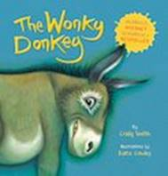](https://shop.scholastic.co.uk/products/126982)

Poppy Field, Michael Morpurgo – RRP £6.99, Scholastic Price £4.99 **Half Price Book Fair £2.50**

[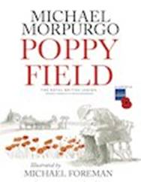](https://shop.scholastic.co.uk/products/119215)

If you have any questions please feel free to come and see me before or after school.

We hope to see you at our book fair.

Miss A Saunders

Class Teacher

The Ellis C of E Primary School

01226 753383