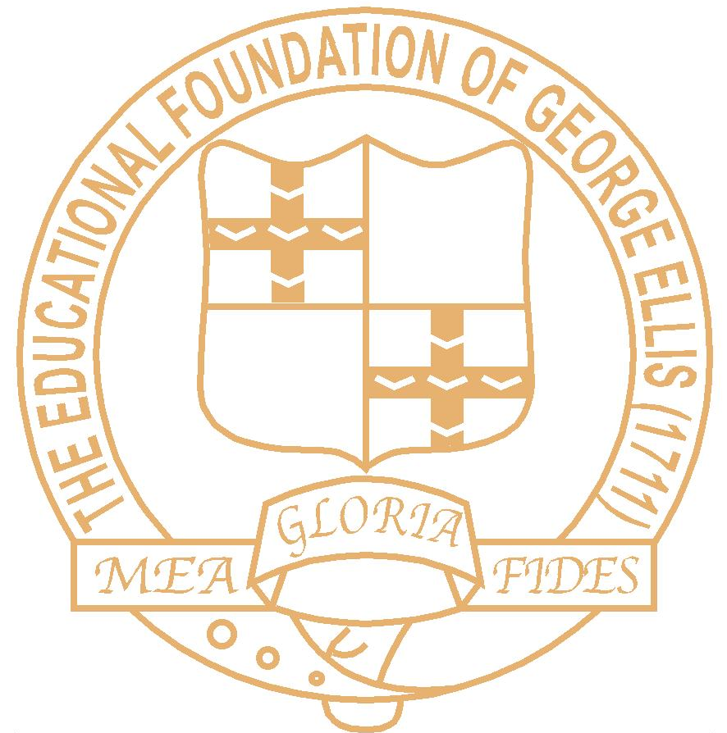
THE ELLIS CHURCH OF ENGLAND PRIMARY SCHOOL
SCHOOL STREET, HEMINGFIELD
BARNSLEY S73 0PS
Metropolitan Borough of Barnsley
Headteacher: Mrs R Hurding
www.theellisschool.org.uk

Telephone: 01226 753383

23 November 2018

Dear Parents/Carers

I am pleased to inform you that the Governing Body have agreed to support eligible working parents by offering free childcare of 30 hours in our nursery, on a trial basis from January 2019 to July 2019. This offer will be reviewed in preparation for the new academic year starting September 2019.

There will be a maximum of 16 places allocated in nursery for children who can stay for 30 hours and these will be offered in date of birth order.

The session times will be:
Morning session 8.45 – 11.45 = 3 hours
Lunch time 11.45 – 12.45 = 1 hour (a packed lunch from home will be required)
Afternoon session 12.45 – 3.30 = 2.75 hours

30 hours free childcare is offered all day Monday to Thursday plus Friday morning. Should you wish your child to stay all day on Fridays, in accordance with the School’s Charging Policy, you also have the option to purchase the additional 3 hours 45 minutes at a rate of £4.00 per hour. This equates to £15.00 per week and is payable via Parentpay.

To check if you are eligible for 30 hours free childcare and to apply please visit www.gov.uk/get-tax-free-childcare

You will be given an 11 digit code which you must include on the attached application form. Please return the form to school no later than Friday, 30th November 2018. Once we have received any application forms and validated the codes we will allocate places in date of birth order. If your application is successful we will write to you to confirm when the 30 hours childcare can start. Parents are then responsible for re-confirming the code every three months.

More information is available at www.barnsley.gov.uk/services/children-families-and-education/childcare-nurseries-and-family-support/30-hours-free-childcare/

Should you have any questions about any of the arrangements, please don’t hesitate to speak to either Mrs Pollard in nursery or Mrs Rodgers in the office.

Yours sincerely

R Hurding
Mrs R Hurding
Headteacher

