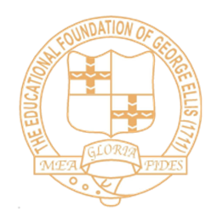
The Ellis KS1/2 Environment Expectations 2016-17

Non- negotiables:
- All classes to have Golden Rules displayed.
- Learning behaviours to be displayed.
- ‘Reach for the Stars’ displayed above green to allow ‘always’ children to progress.
- All classes to have ‘Learning Journeys’ on display/available and kept up to date with evidence of children’s learning.
- Classroom used for working displays to aid learning.
- Corridor and hall used for celebration of work.
- All classrooms to be inviting and purposeful.
- All classrooms to have exciting reading areas.
