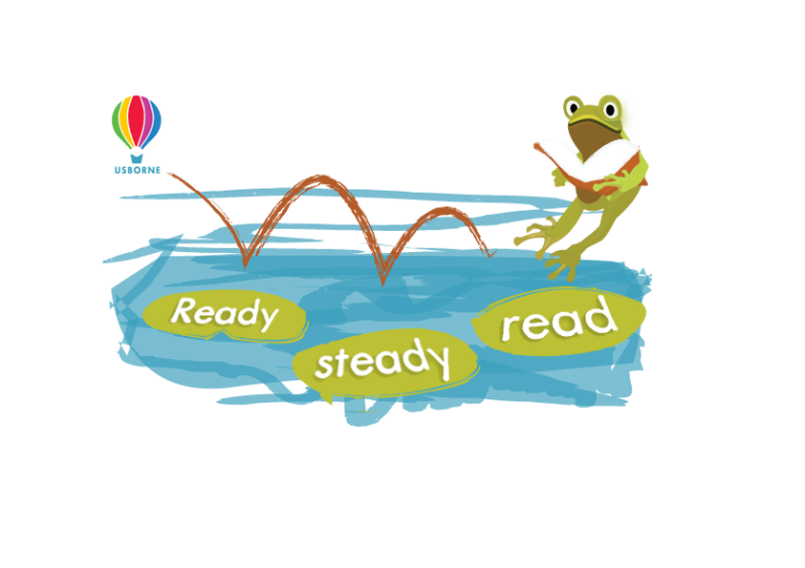

Sponsorship Form

Pupil Name: Class:

Name | Address | Sponsorship  per minute  or  total donation | Amount  collected | Total

Total minutes read
Please return sponsorship money to the school by
Please make cheques payable to

For more information, contact Organiser name and details
or visit us online: www.usborne.com/schools

