Dear Parents/Guardians,

As we are sure you are aware following the recent school email we are changing our homework to ‘home learning’. We would like to explain below what will be sent out each half term and each week.

Home Learning Projects
During the Autumn term our magnificent maples (year 5) produced some amazing home learning projects, we were overwhelmed by the effort that was put into these, and, feel that these are a worthwhile learning experience. Each half term, as we begin a new topic, children will be asked to complete a home learning project (just like what was expected when asked to do the Tudor home learning projects). These, as before, will be open ended, we want children to play to their strengths and interests. We will of course, provide a list of possible ideas, but this is by no means a restrictive task. Pupils will have the majority of the half term to complete this project, allowing time in the remaining two weeks to present their project to their peers.

Reading
It is vital that you encourage your child to continue reading at home, reading diaries were sent home during September, please ensure that these are signed and sent back daily. Your child will be awarded dojos for reading at home. In order to further develop your child’s comprehension skills, whilst you are listening to them read, please ask them questions, for example: how is the main character described? In what ways does the author make you feel happy/worried/scared? Can you predict what might happen next? Questioning will help deepen your child’s learning.
Please note, although books are highly important, it is fully understood that reading materials can be accessed through the internet, ipads, kindles, etc. these should not be discouraged and can also be noted down in your child’s reading diary. Additionally, sources such as football programmes, articles, etc. are a fantastic way to get your child to read (especially if they are a reluctant reader).

Spellings
The children all have both the year 3/4 and year 5/6 spelling lists in their home learning books. A good strategy for learning spellings is to use the strategy ‘LOOK – COVER – WRITE – CHECK’. This follows the simple process of LOOK (allow your child the chance to look at the word), COVER (as it says cover it up, no peeking!), WRITE (write the word down), CHECK (check the spelling against the word, discussing what errors have been made if any). Repeat the process as they practise the word again. It is also important that your child understands the meaning of the word, therefore, they may wish to look up the meaning, and put the word into a sentence.

Maths
It is absolutely essential that your child knows their times tables by heart, knowing their multiplication tables will allow your child to be a more confident mathematician. It will help with mental arithmetic, division, fractions, decimals, shape, etc. The children have lots of fun in lessons playing different multiplication games, they should now be armoured with these skills to have a go at home with whoever they may live with. Also, by giving them quick fire questions, this will help your child’s rapid recall skills.
In addition to this children also enjoy playing countdown, this helps them embed their mathematic skills, such as, multiplying, adding, dividing, subtracting, to name a few. It can be accessed through the ‘nrich’ website. Please see the year 5 calculation policy for any tips you may need.

If you have any questions regarding the above information, please don’t hesitate to come and speak to me.

Thank you for your continued support.

Miss Saunders

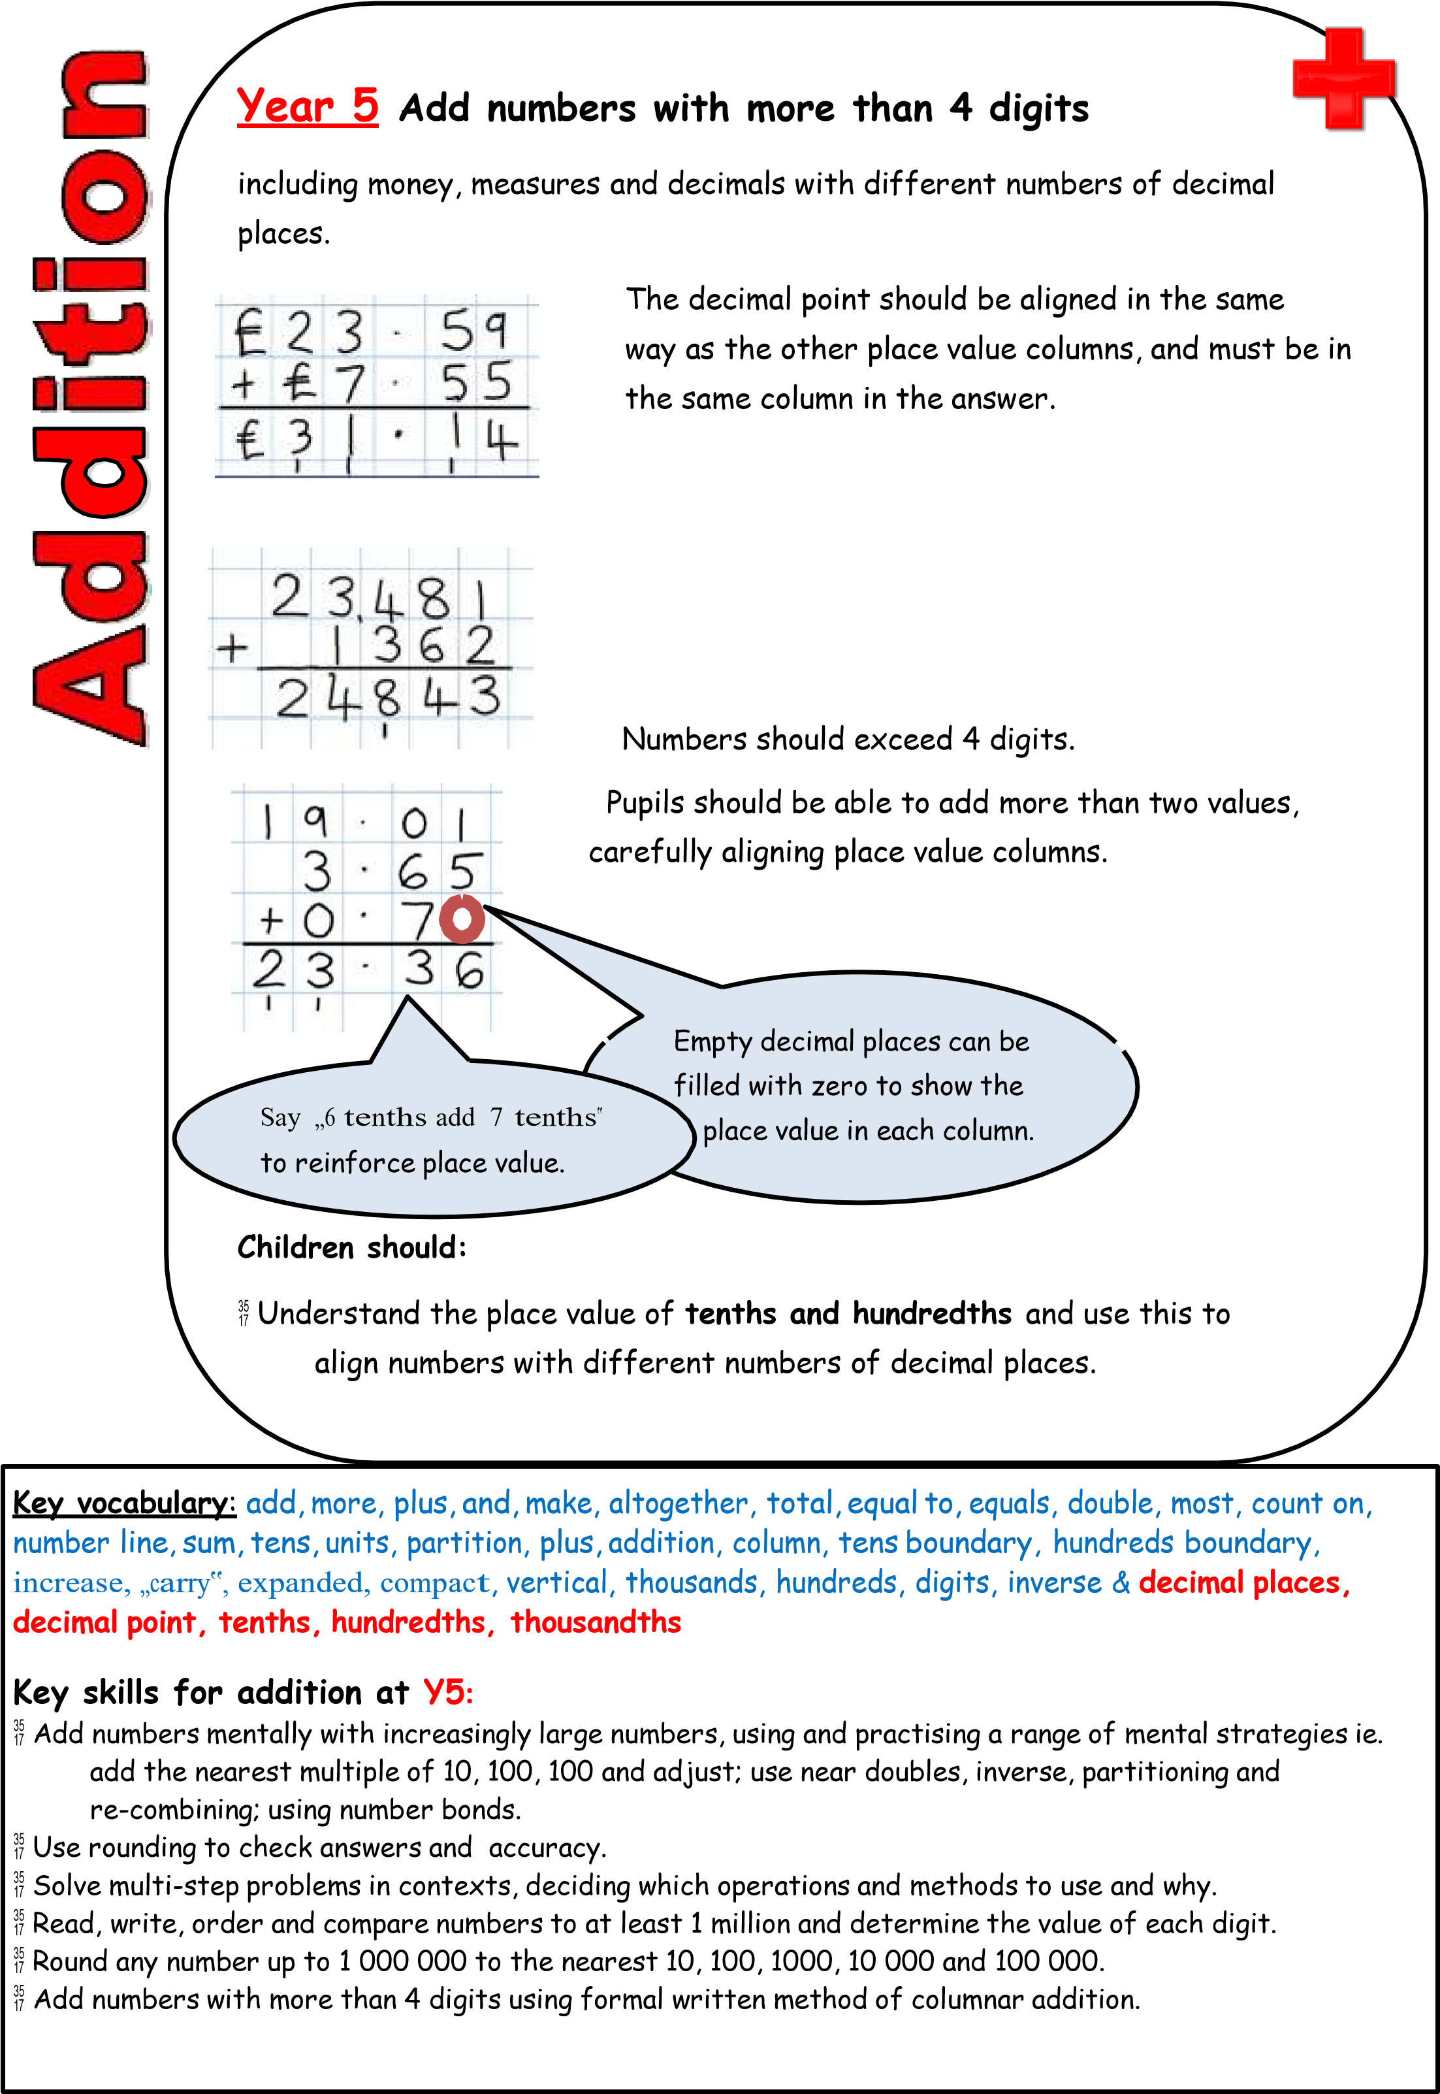
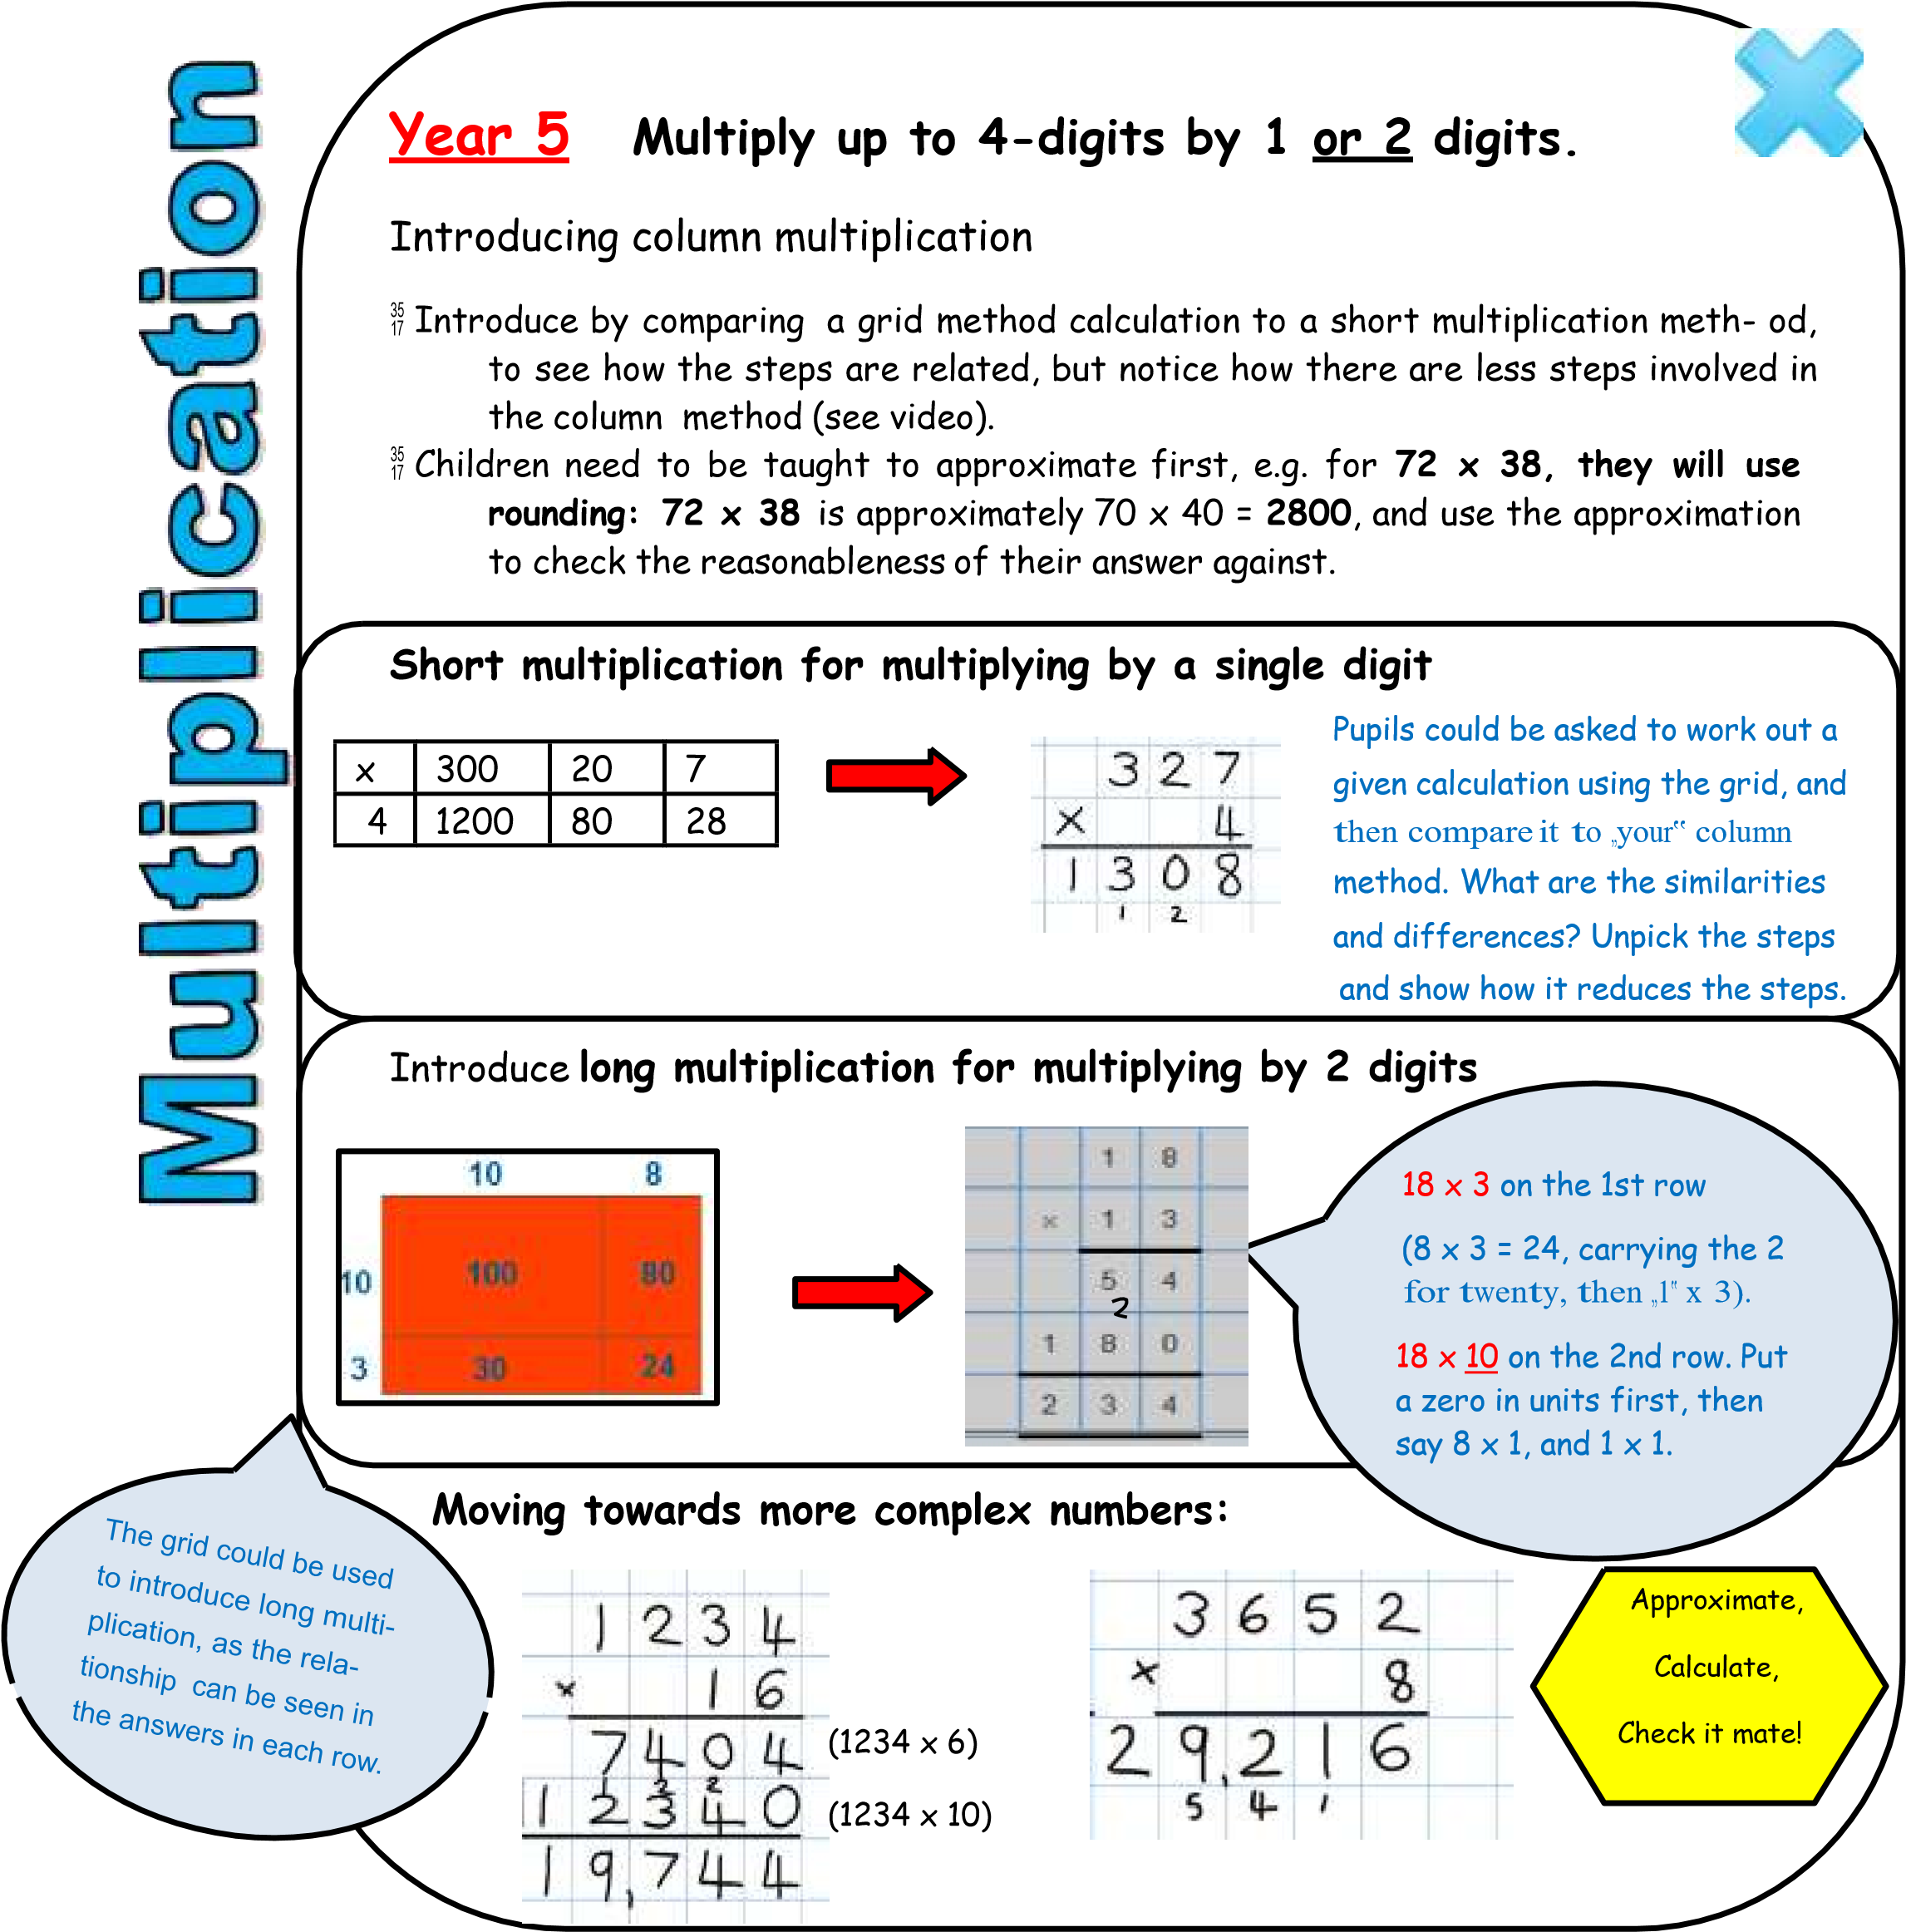

Key vocabulary groups of, lots of, times, array, altogether, multiply, count, multiplied by, repeated ad- dition, column, row, commutative, sets of, equal groups, _times as big as, once, twice, three times..., parti- tion, grid method, total, multiple, product, inverse, square, factor, integer, decimal, short/long multi- plication, ‗carry‘
Key skills for multiplication at Y5:
Identify multiples and factors, using knowledge of multiplication tables to 12x12.
Solve problems where larger numbers are decomposed into their factors
Multiply and divide integers and decimals by 10, 100 and 1000
Recognise and use square and cube numbers and their notation
Solve problems involving combinations of operations, choosing and using calculations and methods appropriately. Video clips:
Moving from grid method to a compact method Reinforcing rapid times table recall:
Demonstration of long multiplication

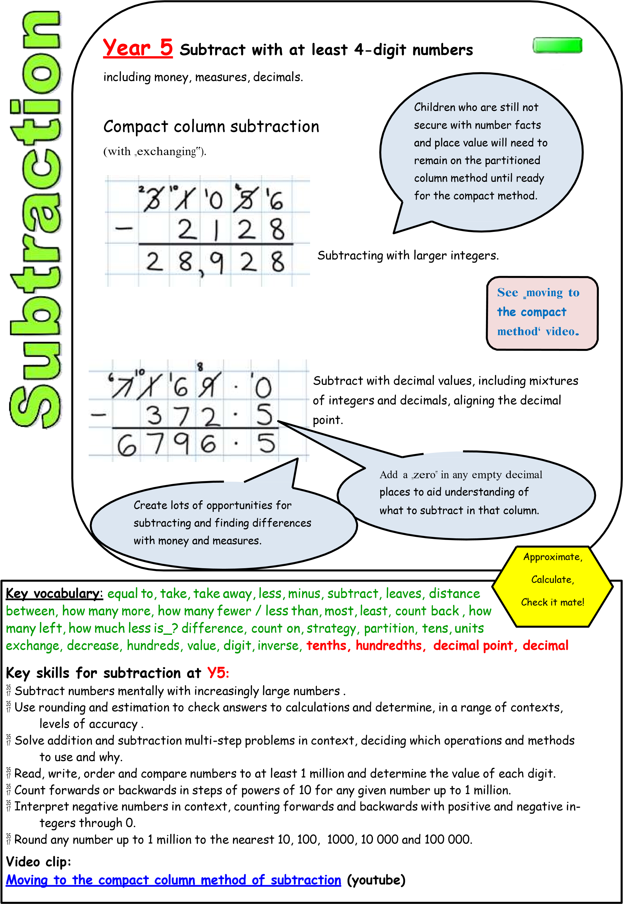

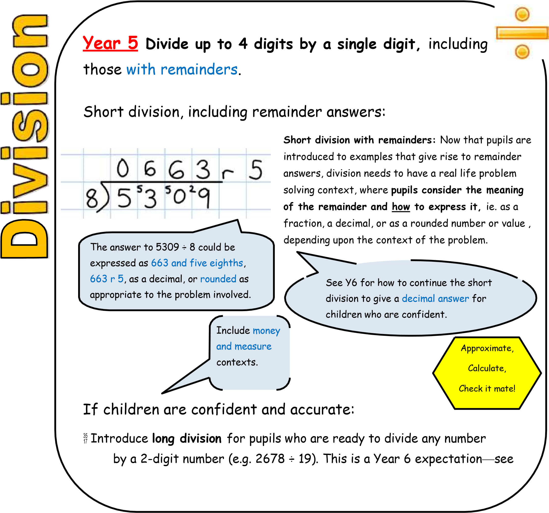

Key number skills needed for division at Y5:
• Recall multiplication and division facts for all numbers up to 12 x 12 (as in Y4).
• Multiply and divide numbers mentally, drawing upon known facts.
• Identify multiples and factors, including finding all factor pairs of a number, and common factors of two number.
• Solve problems involving multiplication and division where larger numbers are decomposed into their factors.
• Multiply and divide whole numbers and those involving decimals by 10, 100 and 1000.
• Use the vocabulary of prime numbers, prime factors and composite (non-prime) numbers.
• Work out whether a number up to 100 is prime, and recall prime numbers to 19.
• Divide numbers up to 4 digits by a one-digit number using the formal written method of short division and inter- pret remainders appropriately for the context • Use multiplication and division as inverses.
• Interpret non-integer answers to division by expressing results in different ways according to the context, includ- ing with remainders, as fractions, as decimals or by rounding (e.g. 98 ÷ 4 = 24 r 2 = 24¹/2 = 24.5 ≈ 25).
• Solve problems involving combinations of all four operations, including understanding of the equals sign, and includ- ing division for scaling by different fractions and problems involving simple rates.

