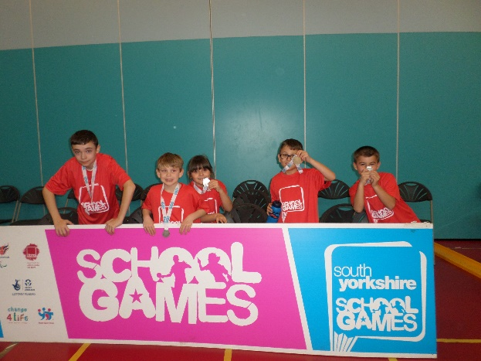
The Ellis C of E School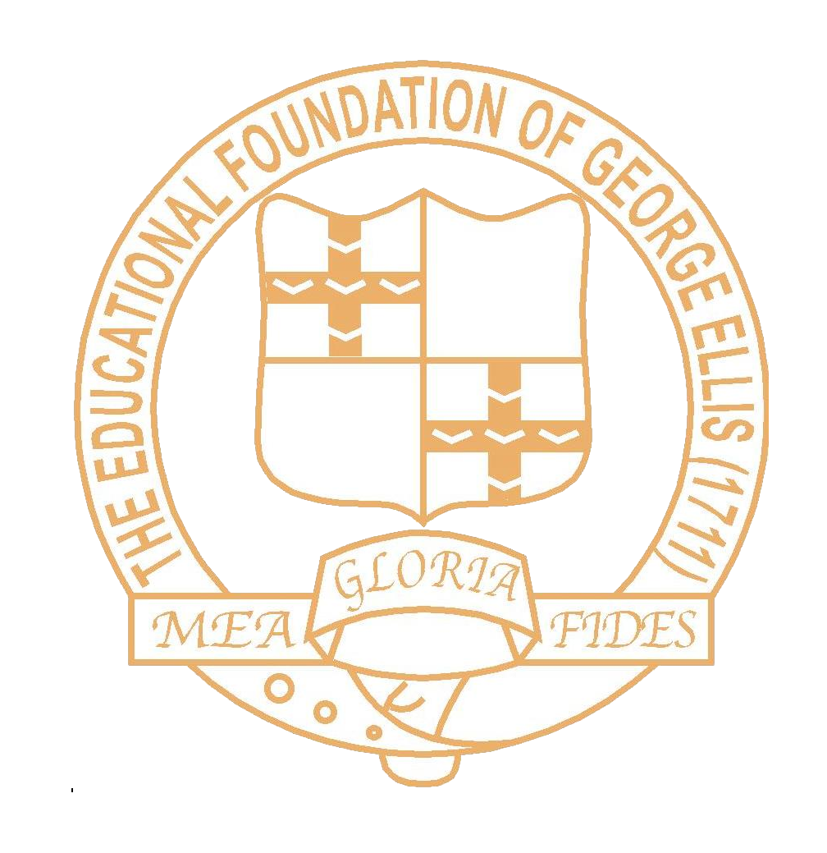
Miss N Cook

Sports Premium Grant
Report April 2017
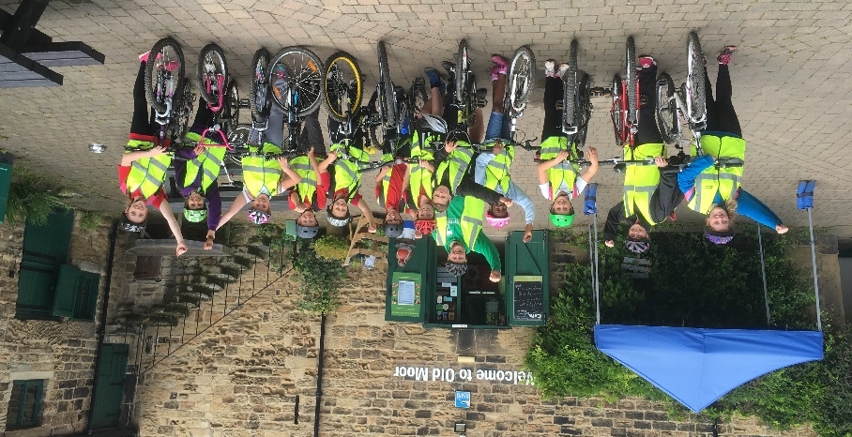
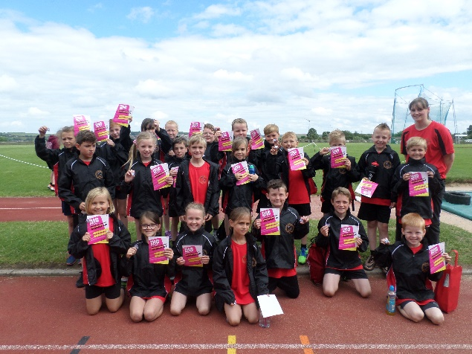
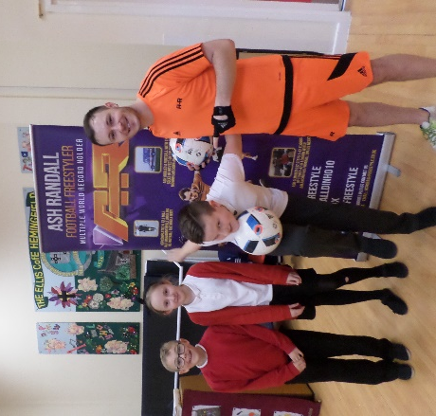
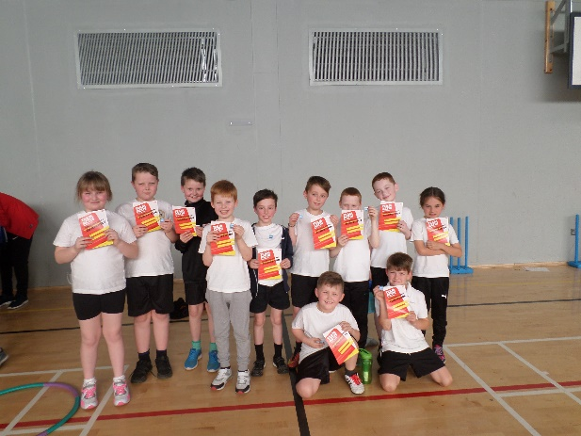
Summary of SPG Spending Academic Year 2016-2017
Objectives in spending SPG:
- School Improvement Priority - To effectively spend the PE funding to ensure standards in the subject are raised and can be maintained in the long term

- Key outcomes - Improved pupil participation rates in after school clubs, intra and inter school sports.

- Summative Evaluation Strategies - Staff training, planning, photographic evidence, pupil + staff questionnaires, analysis of uptake for after school clubs
Summary of spending and actions taken
Sports Premium Grant 2016-2017: £8000 + £5 for every child in KS1+2

Curriculum Aims | Intended Outcome/ Impact for 2016-2017
Aim 1 - Continue to develop a curriculum that provides children to a broad range of physical activities | - To look at purchasing a new/ updated scheme to teach in PE  - To look at purchasing a new uniform / kit with the school emblem on for sports competitions and events  - To ensure high quality PE is taught across all Key Stages  - To attend CPD courses to keep up to date with any curriculum changes
Aim 2 - Ensure children are physically active for sustained periods of time | - To ensure all children take part in PE  - Provide training to Year 5 pupils to enable them to be Playground Leaders (regularly running activities throughout lunch and break times that is pupil led)  - To promote after school clubs and increase participation rates further  - To provide a range of sporting experiences for children both in and out of school
Aim 3 - Engage children in competitive and non-competitive activities | - To participate in a higher number of inter and intra school competitions  - To target specific children to encourage attendance at after school clubs.
Aim 4 – Promote healthy, active lives to children | - To encourage all children to travel to school using sustainable transport  - Promote healthy active lifestyles outside of PE e.g. in the classroom, in other curriculum areas

Aim 1 - Continue to develop a curriculum that provides children to a broad range of physical activities
  - To look at purchasing a new uniform / kit with the school emblem on for sports competitions and events
  - To attend CPD courses to keep up to date with any curriculum changes

- The Ellis offers a broad curriculum through a variety of sports taught in PE from Foundation Stage.
- The Ellis continues to offer after school clubs every term focusing on a different sport and taught by specialist coaches from Team Activ to ensure children are getting high quality provision.
- We have created an additional after school club so there is now a club for both key stages running every week. These clubs have become oversubscribed and we are constantly evaluating them and looking to add additional clubs. We also have 2 football clubs running after school to accommodate children from both Key Stage 1 and Key Stage 2.
- From Foundation Stage up to Year 4, fundamental movement skills are now taught instead of teaching a half term on one specific game. This has developed the children’s running, throwing, catching, jumping, kicking and balancing skills and has allowed more time to consolidate these skills.
- New outdoor equipment has been purchased to develop the gross motor skills of children in the foundation stage.
- Money from the SPG has been used to develop the outdoor area of Key Stage 1. This has enabled the key stage to teach much more physical numeracy and literacy. The children regularly learn outdoors through practical activities.
- A new PE scheme has been researched and the PE coordinator is in discussion with Team Activ and other schools before purchasing one. Staff are attending a Real Gymnastics Course on 3/4/17 where the staff will receive 2 year group’s plans for gymnastics. On 24/3/17 the PE coordinator attended an outdoor educational course at Thornbridge Outdoors and received a scheme of work to support the teaching of outdoor and adventurous activities. As a result, we are looking to develop our outdoor area further by creating an orienteering course by summer 2017.
- To ensure The Ellis is up to date with changes in the curriculum the PE Coordinator has attended the Barnsley PE Conference on Monday 20th June 2016 and is booked to go again this year.
- A new kit has been purchased for the children to wear at events. This has inspired the children and made them feel more part of a team. It has improved standards as all children now attend events wearing appropriate kit as this wasn’t always the case in previous years. The children are proud to wear the kit at events and competitions and feedback from parents and other schools has been very positive.

Aim 2 - Ensure children are physically active for sustained periods of time

- All classes receive a minimum of 2 hours timetabled PE. In addition to this, Foundation Stage 2 take part in Write Dance sessions to develop their gross and fine motor skills.
- Energy Club is also offered 3 times per week during break times for the children to receive 15 minutes high intensity sport in a fun environment.
- Lunchtime supervisors also run sport led activities and music is on every lunchtime to encourage children to move and dance, who otherwise would have been sedentary.
- New playground equipment has been purchased to support these activities such as the ball shooter which encourages children to be active at every break/ lunch time whilst also improving their accuracy in shooting.
- From March 2017 we have launched the Daily Mile in school. This is being run 3 times per week by Team Activ at lunchtimes and every class is also running 1 additional session.
- From March 2017, Team Activ have also ran a lunch time physical activity on the muga additional to the Daily Mile.
- Staff as well as children have been motivated by the daily mile in school. Staff regularly take part in the Daily Mile and in addition some staff members have started a walking club after school.
- Children from Year 6 act as Playground Leaders and run a range of activities at lunch times.
- Children from Nursery Stage upwards are offered the opportunity to take part in Sports Day during the summer term.
- Additional after school clubs have been paid for out of the SPG as the current after school clubs are becoming oversubscribed.

As of Easter 2017

From the graphs it is clear to see that we have a much higher percentage of children across key stages 1 and 2 that have attended clubs so far this year. The SPG money has enabled The Ellis to pay for coaches/ transport to and from events and therefore we have been able to attend many more competitions.

As a school our main aim was to ensure everyone within school regardless of ability would have the opportunity to attend a sports competition every 2 years. As of April 2016 (Easter holidays), 68% of the school had attended a competition or had access to a sports event. See figure below.

Table 1 - Overview of the after school clubs run throughout 2016/17
After School Club | Half Term  1 | Half Term  2 | Half Term  3 | Half Term  4 | Half Term  5 | Half Term  6
Key Stage 1 | Multi Skills | Multi Skills | Gymnastics | Multi Skills | Athletics | Athletics
Key Stage 2 | Zumba | Gymnastics | Tag Rugby | Basketball/ netball | Cricket | Athletics
Both Key Stages | Football | Football | Football | Football x 2 | Football x 2 | Football x 2

We wouldn’t achieve our target of increasing participation unless we use the SPG to provide an extra after school club. As of Spring 2 term we have provided an extra football club to Key Stage 2 children as the Tuesday club is over subscribed. We now have sports clubs running after school 4 days a week and have used the SPG money to support the cooking club on Mondays.

Aim 3 - Engage children in competitive and non-competitive activities

- As a school we have continued our membership with Team Activ.
- Each half term competitions are available for all keys stages to take part. This year, so far, we have taken part in Years 1/ 2 Multi Skills, Years 3/ 4 Multi Skills, Year 5/6 sports hall athletics, Years 3/ 4 sports hall athletics and Year 5/ 6 football which we reached the finals of and had a finals competition at Honeywell Site, Barnsley.
- Pupil Premium and SEN children have had the opportunity to attend more non – competitive inclusive events. We have also qualified for the School Games Kurling event as a result of this. In March we attended the School Games event and we achieved silver in kurling.
- By the end Term 1, 93% of children in Key Stage 1 had attended an after school club or extra-curricular sports event off site. The 7% who hadn’t were targeted in Term 2 and given first priority at clubs/ events.
- Achievements from these competitions have been shared in assemblies with children being presented with badges and certificates and on the school’s website/ Facebook page.
- We have had a number of speakers/ activities with athletes from a range of different sports to inspire and motivate children to take part in physical activity.

Aim 4 - Promote healthy, active lifestyles to children

- The Ellis works in a partnership with Sustrans Bike Charity. Through involvement with Sustrans we have been able to provide the children with a Get off Stabilisers session for Key Stage 1 and Foundation Stage 2, Bike Ability in Year 5, Cycle Skills for Years 4 and 5, Bike Maintenance Sessions, Dr Bike.
- Children took part in “The Big Pedal 2016.”For 2 weeks children were encouraged to come to school on their bikes or scooters, promoting a healthy, active means of travel whilst also easing congestion around the school gates. This was supported by some staff also changing their usual mode of transport to a healthier throughout the 2 weeks. A Bike It Breakfast (a healthy breakfast consisting of juice, croissants, yoghurts and fruit) was provided to all children who arrived via bike or scooter. Parents were also encouraged to join in with the competition. We were runners up in the Barnsley Area and aim to improve on this next year.
- We have worked with Barnsley Council to carry out the Wow scheme in school. This encourages children to walk at least once a week to school. Children earn badges and prizes the more times they walk or come to school using walking, biking or scooting. We have been awarded the Bronze award from Modeshift.
- Children in all year groups have an opportunity to bake and cook to develop their knowledge of food. Children in Year 3 complete a term on the topic Diet and Fitness and gain a good understanding of what makes a healthy lifestyle and how the body works. Classes are also encouraged to use the Farm to Fork initiative from Tesco to go on a supermarket visit and receive a return in school visit which focuses on healthy food.
- A new cookery club has been set up by the Year 5 teacher where children get the opportunity to learn about food and cook quick, healthy meals for themselves and their families. Equipment for this has been paid for by the SPG.

A summary of the main improvements from April 2016 – April 2017

- Competitions and events for SEN / PP and vulnerable children better attended
- Awarded Bronze for Modeshift Stars
- Awarded Silver in School Games
- Outdoor learning areas provided by SPG for Foundation and Key Stage 1
- Increased participation levels in extra-curricular clubs
- Extra clubs been provided out of SPG
- A broad range of clubs including cookery club supplemented by the SPG
- Attendance at competitions increased
- A School Games event attended at the EIS
- Athletes and local sports stars paid to come into school and run demonstrations and assemblies inspiring and motivating the children to take up sports.
- Better links developed with local clubs.
  - 5 children now attend a local tennis club (Improved from 1 child in 2015/16)
  - Children taken on by Hoyland Magpies as a result of Tuesdays after school football club.
  - Many children attend cricket clubs in the local area
  - Regular emails sent out about local clubs ran by Team Activ
  - Many children in school attend a local basketball club set up by Team Activ

Next Steps…
- Aim 1 –
  - To look at purchasing a new/ updated scheme to teach in PE
  - To attend more CPD courses to develop our teaching

- Aim 2 –
  - To maintain and improve on current participation rates in extra-curricular and competitive events in school
  - To attend more school games events by summer 2018

- Aim 3 –
  - To run our own intra school sports event in school
  - To train lunch time supervisors to deliver more physical activities at lunch time

- Aim 4 –
- To develop a daily mile club in school that is ran by school staff
- To train all staff on fundamental movement skills
- To develop an orienteering course in school
- To give all teaching staff training on outdoor and adventurous activities
N Cook – (All information correct as of April 2017)

Target  linked to the whole school plan | Action  Description of activity | Expenditure  Items and cost | Impact on pupils  Qualitative, quantitative, quotes
Aim 1 - Continue to develop a curriculum that provides children to a broad range of physical activities | - Attend PE conference to keep up to date with curriculum changes  - Ensure children receive high quality PE for a minimum of 2 hours per week.  - Equipment to carry out high quality PE | Cost of supply cover for the conference £120 | Children receive up to date Primary curriculum. Gain new ideas and initiatives to be developed around PE and keeping healthy.
Aim 2 - Ensure children are physically active for sustained periods of time | - To ensure all children take part in PE  - Provide training to Year 5 pupils to enable them to be Playground Leaders (regularly running activities throughout lunch and break times that is pupil led)  - To promote after school clubs and increase participation rates further  - To provide a range of sporting experiences for children both in and out of school | Playground leader training delivered as part of the membership package with Team Activ.  Additional after school clubs provided £35 per hour  Coach company cost (£90-£240) | Children active at break times and also having an opportunity to lead games.  More children attending after school clubs therefore more of our children are active for an extra hour per week  Better variety of clubs. Children have had the opportunity to take part in Zumba and cooking club.  More children have attended sporting events run by Team Activ
➢ Aim 3 - Engage children in competitive and non-competitive activities | - New ball shooter on the playground  - Continue membership to Team Activ  - To participate in a higher number of inter and intra school competitions  - To target specific children to encourage attendance at after school clubs.  - New uniform to attend sports events. | Ball shooter - £1650  £1896 – Team Activ membership  An intra school sports event has been organised by The Ellis School and Team Activ.  Coach costs to competitions  (£90-£240) | Children play with the ball shooter daily making sure they are active at break times and developing their shooting skills.  Children on the PP/ SEN register have been given the opportunity to attend a higher number of non -competitive events in a variety of sports.
Aim 4 – Promote healthy, active lives to children  ➢ | - Year 3 children took part in a first aid day run by St John’s Ambulance to learn about basic first aid  - To encourage all children to travel to school using sustainable transport  - Promote healthy active lifestyles outside of PE e.g. in the classroom, in other curriculum areas | Equipment for cooking club £50  £77 St John’s ambulance | 8 children every half term have the opportunity to learn about food and cook healthy meals.  KS2 children and parents have learned a basic knowledge of first aid skills.

Year 5 / 6 netball
Year 3 / 4 Hockey

