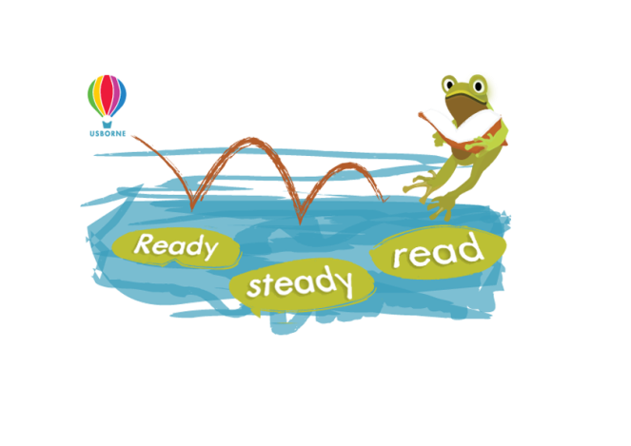

Reading Log

Pupil Name: Class:

Day | Minutes Read | Parent Signature | Total
Monday
Tuesday
Wednesday
Thursday
Friday
Saturday
Sunday

Total minutes read

www.usborne.com/schools

